EPIDEMIOLOGICAL SURVEILLANCE AND MOLECULAR CHARACTERIZATION OF ZOONOTIC GASTROINTESTINAL PARASITES IN UNDERSTUDIED WILD NON-HUMAN PRIMATES IN TANA RIVER, TRANS NZOIA AND SAMBURU COUNTIES IN KENYA

CAROLINE JERONO L

A Thesis Submitted to the Department of Medical Laboratory Science in Partial Fulfillment of the Degree of Master of Science in Medical Parasitology and Entomology of the Jomo Kenyatta University of Agriculture and Technology

2026

DECLARATION
This thesis is my original work and has not been presented for a degree award in any other University.

Signature: ……………………………………… Date: …………………………………….
Jerono Caroline L. (HSB 327 0247/2021)

Declaration by Supervisors
This thesis has been submitted for examination with our approval as supervisors.

Signature: ……………………………………. Date: …………...…………………………
Dr. Steven Ger Nyanjom Biochemistry Department,
Jomo Kenyatta University of Agriculture and Technology (JKUAT)

Signature: ……………………………………. Date: ………...……………………………
Dr. Mercy Yvonne Akinyi, Animal Science Welfare and Ethics Directorate,
Kenya Institute of Primate Research (KIPRE)

Signature:……………………………………. Date: …...………………………………….
Dr. Luna Kamau, Center for Biotechnology Research and Development,
Kenya Medical Research Institute (KEMRI)

DEDICATION
I dedicate this work to my dear dad Mr. Paul Francis Lagat, my spouse Mr. Marck Calely who have been my mentors and more to that offered me financial and moral support through this journey and my son Iyk Calely.

ACKNOWLEDGEMENT
I would like to thank the Almighty God for enabling me to come this far. I wish to acknowledge my supervisors Dr. Mercy Akinyi, Dr. Steven Ger Nyanjom and Dr. Luna Kamau for their profound guidance throughout my project and study. I would also like to thank the Kenya Wildlife Services, Kenya Institute of Primate Research where I did my lab work and local communities in Tana River and Trans Nzoia counties, where samples were collected. Special mention goes to our field assistants in Tana River and Trans-Nzoia: Gift Thoya, Purity Oreng’, Said Rhova, Mohamed Komora, Gafo, Paxton Kabasa and John Muwana Lusweti, who help with sample collection. Finally, I am also highly indebted to the Organisation of Women in Science in Developing Countries, Early Career Grant Award, which, through funding of Dr. Mercy Akinyi (2020-2023), made this work possible.

TABLE OF CONTENTS
DECLARATION i
ACRONYMS AND ABBREVIATIONS viii
ABSTRACT ix
CHAPTER ONE 11
BACKGROUND INFORMATION 11
1.1 Introduction 11
1.2 Problem Statement 13
1.3 Justification 15
1.4 Study Objectives 16
1.4.1 General Objective 16
1.4.2 Specific Objectives 16
1.5 Research Questions 16
CHAPTER TWO 17
LITERATURE REVIEW 17
2.1 Human and Non-human Primate Interaction and Zoonosis 17
2.2 Zoonotic Diseases 18
2.2.1 Zoonotic Diseases in the Non-human Primate Population 18
2.2.2 Zoonotic Gastrointestinal Parasites 19
2.2.3 Factors that Influence GIT Parasite Transmission 27
2.3 Diagnosis and Treatment 28
2.4 Research Gap 30
CHAPTER THREE 31
MATERIALS AND METHODS 31
3.1 Study Site 31
3.2 Study Population and Sample Distribution 32
3.3 Study Design and Sample Collection 2
3.4 Microscopic Screening Techniques 3
3.4.1 Fecal Parasitology 3
3.3.2 Molecular Screening 4
3.3.3 Sequencing Analysis of Entamoeba Spp. 2
3.4 Statistical Analysis 3
3.5 Ethical Considerations 3
CHAPTER FOUR 4
RESULTS 4
4.1 Prevalence of Zoonotic Gastrointestinal Parasites 26
4.2.1 Molecular Screening of Parasite Species 30
4.3 Phylogenetic Analysis of Parasite Species 31
4.4 Sensitivity and Specificity of Diagnostic Tests 33
4.4.1 Microscopy vs PCR Detection of Entamoeba 33
4.4.2 Microscopy vs PCR Detection in Nematodes 37
4.5.3 Microscopy vs PCR Detection of Trichuris 39
CHAPTER FIVE 42
DISCUSSION, CONCLUSIONS AND RECOMMENDATIONS 42
5.1 Discussion 42
5.1.1 Introduction 42
5.1.2 Prevalence of Zoonotic Gastrointestinal Parasites among NHPs 42
Mangabey Monkeys 44
Sykes Monkeys 44
Red Colobus and Black and White Colobus Monkeys 45
De Brazza’s Monkeys 45
5.1.3 Molecular Characterization and Phylogeny of Parasite Species 48
5.1.4 Performance of the Diagnostic Tests 49
5.2 Conclusion 53
5.3 Recommendations 54
5.4 Limitations of the Study 54
REFERENCES 55

LIST OF FIGURES
Figure 2.1: Nematode Life cycle and stages 8
Figure 2.2: Fecal Oral Life cycle of gastrointestinal protozoan parasites. 11
Figure 3.1: Map of Kenya showing counties. 19
Figure 3.2: Selected non-human primates sampled 20
Figure 4.1: Parasite richness and infection burden across locations and host species. 26
Figure 4.2: Bars representing the estimated parasite prevalence across sampled non-human primates. 28
Figure 4.3: PCR Gel images 30
Figure 4.4: Phylogenetic tree of Entamoeba identified in NHPs. 32
Figure 4.5: Diagnostic performance of microscopy relative to PCR for overall Entamoeba detection 33
Figure 4.6: Diagnostic performance of microscopy relative to PCR for overall nematode detection 36
Figure 4.7: Diagnostic performance of microscopy relative to PCR for overall Trichuris detection. 38

LIST OF TABLES
Table 2.1: Summary of Gastrointestinal parasite studies done on Non-human Primates in Kenya 14
Table 3.1: Parasite target and Primers 22
Table 4.1: Sample Size Distribution of Understudied Non-Human Primates (NHPs) Across Three Counties 25
Table 4.2: BLAST results of amplified Entamoeba species against NCBI 31
Table 4.3: Microscopy–PCR 2 × 2 classification matrix for nematode parasite detection 35
Table 4.4: Microscopy–PCR 2 × 2 classification matrix for nematode parasite detection 37
Table 4.5: Microscopy–PCR 2 × 2 classification matrix for Trichuris parasite detection 40

ACRONYMS AND ABBREVIATIONS
NHP – Non-Human Primates
ITS – Internal Transcribed Spacer
DNA – Deoxyribonucleic acid
WHO – World Health Organization
GIT – Gastrointestinal Tract
TH2 – T- Helper 2 cells
TH1 – T- Helper 1 cells
IL – Interleukin
IgE – Immunoglobulin E
IFN – Interferon gamma
TNF – Tumor Necrosis Factor
NaCl – Sodium Chloride
Rpm – Revolutions per minute
PCR – Polymerase Chain Reaction
ELISA – Enzyme Linked Immunosorbent Assay
EIA – Enzyme Immunoassay
WHO – World Health Organization

ABSTRACT
Free-ranging non-human primates (NHPs) are important reservoirs and sentinels for zoonotic pathogens because of their close ecological and physiological relationship with humans. This study investigated the prevalence, co-infection burden and phylogenetic relationships of gastrointestinal parasites among NHPs in Tana River, Trans Nzoia and Samburu counties, Kenya. A total of 148 fecal samples were collected from Cercopithecus mitis albotorquatus (n = 11), Cercocebus galeritus (n = 30), Piliocolobus rufomitratus (n = 19), Cercopithecus neglectus (n = 41) and Colobus guereza (n = 47). The study identified and characterized circulating parasites in fecal samples of selected NHPs using microscopic and molecular screening.
Entamoeba was reported as the most prevalent parasite (71.6%) and Balantidium (31.8%), while Strongyloides (16.9%), Eimeria (12.8%) and Trichuris (11.5%) showed moderate prevalence. Entamoeba prevalence differed across locations (χ² = 6.13, p = 0.047), while Balantidium showed strong site-specific clustering, Trans Nzoia (65.3%), Tana River (18.3%) and Samburu (10.3%) (χ² = 38.76, p < 0.001). Host-associated differences was observed, with Balantidium being common in De Brazza’s monkeys and black-and-white colobus, while Trichuris was frequent in Sykes.
Molecular screening of 109 samples detected Entamoeba spp. in (81) samples, nematodes using universal nematode primers (32) and Trichuris spp. (4). Phylogenetic analysis identified four distinct Entamoeba clades, with sequences from black-and-white colobus, red colobus and De Brazza’s monkeys clustering with reference sequences reported from humans and baboons.
Microscopy and PCR differed in performance depending on the parasite target. For Entamoeba, microscopy sensitivity was (81.5%) and specificity (60.7%) when PCR was used as the reference method, with no significant difference in paired positivity between microscopy and PCR (McNemar’s p = 0.557). For Trichuris which is classified as a nematode, microscopy sensitivity was (50.0%) and specificity (84.8%), but PCR detected fewer positives and paired positivity differed significantly between both methods (McNemar’s p = 0.001). The findings demonstrate significant host-associated and geographic heterogeneity in gastrointestinal parasite distribution among NHPs and highlight the importance of integrating microscopy and molecular approaches for parasite detection, biodiversity assessment and zoonotic risk surveillance at the human–wildlife interface.

CHAPTER ONE

BACKGROUND INFORMATION

1.1 Introduction
Humans and wildlife have always coexisted though several factors have compromised this status quo. The rapid human population growth has led to dramatic increase in the number of people living in close proximity with wildlife and hence increased scramble for resources between humans and wildlife (King et al., 2007). The human population is projected to rise two folds by 2050 and with this human-wildlife interaction is expected to increase as a result of human encroachment to the wildlife conservancy regions (Thuku et al., 2013). Human-wildlife interaction thus has important consequences to human, wildlife and ecosystem health as well as biodiversity. The loss of biological diversity as a result of anthropogenic activities such as forest fragmentation has led to the emergence of parasitic diseases which is a serious threat to humans and many animal species including endangered ones (Mbora & McPeek et al, 2009). Increased food competition and agonistic interactions among animals increases stress levels hence compromising immunocompetence and lowering resistance to these infections (Meyer & Hamel et al, 2014) .
Despite this compelling evidence of land encroachment and increased human wildlife interaction, a few studies have been conducted to determine the risk factors which increase the chances of transmission of zoonotic pathogens (Cunningham et al., 2017). Wildlife are known to be an important source of infectious diseases transmissible to human. Zoonotic pathogens transmitted between animals and humans include viruses such as Ebola in West Africa, bacteria such as Anthrax, Salmonella, Shigella and Staphylococcus (Suer,et al., 2014) and gastrointestinal parasites such as helminthes and protozoa (Munene, et al., 2006). Zoonotic gastrointestinal parasites are among the commonest zoonotic diseases and infections that occur through accidental intake of contaminated food and water (Singh, 2014). Apart from humans, livestock also suffer the diseases transmitted by the wildlife while out seeking for pasture and water which poses a high risk to human through possibility of transmission as a result of meat consumption (FAO 2009). Some studies have documented cases where wildlife suffer from diseases which they have acquired from humans (Cunningham et al., 2017). Across the continents, zoonosis with wildlife reservoirs has been a major public health problem affecting humans and therefore call for more attention to be drawn so as to address this problem.
Non-human primates (NHPs) have been thought to be responsible for most zoonotic diseases due to the close relatedness with human (Wolfe et al., 1998), increasing parasitic prevalence as a result of the human primate interactions and land fragmentation (Mbora & McPeek et al, 2009). Zoonotic gastrointestinal helminthes impose both direct (Nesheim et al., 2002) and indirect effects (Johnson & Buller et al., 2011) on hosts. Evidence from studies conducted at the human-wildlife interface in Kenya showed that the NHPs harbor zoonotic parasites like Trichuris trichuria, Schistosoma mansoni and Oesophagostomum (Mbuthia et al., 2021a) (Fredrick et al., 2021) (Akinyi et al., 2019).
The three study sites are regions that support the livelihood of the Non-Human Primates considering that the regions have dense forests supporting the canopy shelter of the species inhabiting the regions. Tana River County has one of the Kenya’s largest rivers (Tana river) which provides a water lifeline for the wildlife inhabiting the region. The County sustains a huge gallery of woodland with approximately 175 tree species providing continuous supply of leaves and fruits forcing even the critically endangered species of the non-human primates including the Tana River Red Colobus and the Mangabey monkeys to inhabit the region (Butynski & Mwangi, 2023). Samburu County has forested highland ecosystem which includes the Mathew Ranges, Ndoto and Mt. Nyiro receiving high rainfall and providing ideal conditions for forest dependent species of the Non-Human Primates. Mathew Ranges hosts populations of the Debrazza, Black and White Colobus monkeys. These group of the Non-Human Primates inhabit the region due to the availability of protected micro-climate and riverine forest galleries (von Hippel et al., 2000). The Black and White Colobus Monkeys inhabit the high-altitude forest away from the human-wildlife conflict zone of the forest (Chirchir et al., 2018). Samburu County hosts Ewaso Ngiro river that provides constant water supply and cuts across the arid lowland. The river sustains dense riverine forests providing livelihood sustainability of the Non-Human Primates (Mwenja, 2007). Trans Nzoia County is located in Western Kenya between Mt. Elgon and Cherangani Hills. The region has dense forests rich in vegetation diversity and abundant water catchment areas. The presence of indigenous trees and shrubs provides dietary components to both frugivorous and folivorous Non-Human Primates inhabiting the region (P. Fashing, 2001). This riverine ecosystem supports the inhabitation of the species like the Debrazza and the Black and White Colobus monkeys in the region (Ej, 1985) (P. J. Fashing, 2001).
The diagnosis of gastrointestinal parasite, non-invasive sampling techniques such as stool sample collection has been widely used to monitor pathogen diversity in threatened and endangered populations coupled with microscopic analysis for parasitic detection and identification (Nemani et al., 2018). Merits of microscopy over molecular include the fact that it is low cost, widely available and straight forward to use (Miswan et al., 2022a). However, owing to the difficulties with conventional protocols such as microscopy which make it difficult to achieve parasitic detection with low parasitemia, researchers have utilized DNA diagnostic procedures- as they are more sensitive and reliable (Morgan et al., 1998). Use of the first and second internal transcribed spacer (ITS) of the nuclear ribosomal DNA has been a substitutional procedure in occasions where parasites look closely identical and in samples where there is extremely low parasitemia (Friehs et al., 2017). Molecular characterization can provide important information about the parasite’s zoonotic potential and transmission dynamics within a community.
This study conducted epidemiological surveillance of gastrointestinal parasites of zoonotic potential among understudied species of the NHPs in Tana River, Trans Nzoia and Samburu counties in Kenya. The species of the NHPs included the Tana River Syke monkeys (Cercopithecus albogularis), The critically endangered Tana River Red Colobus monkeys (Piliocolobus rufomitratus), Tana River Mangabeys (Cercocebus galeritus), Debrazza monkeys (Cercopithecus neglectus), Mau Forest black and white Colobus (Colobus guereza matschiei) and Mathew Range black and white Colobus (Colobus guereza). Through surveillance of understudied species of the NHPs, data obtained from this study will generate knowledge on parasitic genetic diversity among different species of the NHPs and form framework for adopting One Health approach integrating human, animal and environment to help manage parasite transmission.

1.2 Problem Statement
It is estimated that globally, one billion cases of illness and millions of deaths annually are attributed to zoonotic infections. Out of 30 new human pathogens detected in the last three decades, 75% are from the human origin whereas 60% of emerging infectious diseases are zoonotic (Salyer et al., 2017). Pathogen surveillance and response capacity at the human-wildlife interface in most affected countries is limited and is a barrier to controlling the spread of zoonosis. While it is predicted that majority of emerging pathogens from animal origin are viruses, bacteria and parasites such as gastrointestinal helminths and protozoa are however often neglected and hence continue to persist in the environment (Devaux et al., 2019). This is of great concern to the global health security since zoonotic diseases cause morbidity, mortality, economic burden and huge burden on health systems (Tawana et al., 2023).
Natural infections with soil‐transmitted nematodes and protozoa occur in the NHPs and have the potential to cross primate‐species boundaries and cause diseases of significant public health concern in human. Humans living in the human-wildlife interface are more frequently exposed to zoonotic infection as a result of competition for shared resources with wildlife (Edward et al., 2024.). Expanding human populations have forced NHPs into anthropogenically disturbed habitats. This resulting overcrowding and competition for resources has led to disruption of the ecosystem that remained stable for thousands of years leading to continual emergence and acquisition of zoonotic diseases (T. R. Gillespie et al., 2005).
Studies conducted have revealed that there is abundance in gastrointestinal parasite infestation among the non-human primates in Kenya with majority of the frequently reported parasites being the Strongyloides, Trichuris, Oesophagostomum and Trichostrongylus spp, Entamoeba, Balantidium and Eimeria spp. Majority of these parasites have zoonotic potential and the non-human primates are important reservoirs in public health and conservation context (Munene et al., 1998b). A study that was conducted in Amboseli ecosystem which is a human-wildlife-livestock interface similar to Tana River, Samburu and Trans Nzoia Counties identified 22 helminth species across livestock and wildlife species and non-human primates shared several gastrointestinal parasites with livestock suggesting a cross-transmission (Obanda et al., 2019a). The Tana River Mangabeys and Red colobus have also been reported to harbor nematode, protozoan species indicating that non-human primates are potential reservoirs of potentially zoonotic gastrointestinal parasites (D. N. M. Mbora & Munene, 2006). Despite having limited studies conducted in Trans Nzoia and Samburu Counties on gastrointestinal parasites prevalence, Non-Human Primates inhabiting these regions have been reported to have high prevalence of Entamoeba despite each studied species reporting different prevalence rate which could be influenced by their feeding behaviors and ecological factors (Lagat et al., 2026).
Comprehensive epidemiological data on the potentially zoonotic gastrointestinal parasite screening among NHP species in Kenya is still lacking. It is important to strengthen surveillance strategies so as to safeguard the wellbeing of non-human primates like the Tana River Red Colobus and Mangabey which have been listed as critically endangered and living in close proximity with human settlements (D. Mbora & McPeek, 2010). Screening of gastrointestinal parasites in NHP remains a challenge because of limited molecular characterization methods, genetic sequencing of circulating parasite strains to differentiate human, livestock and wildlife variants.

1.3 Justification
Habitat sharing between humans and wildlife resulting from the population growth has greatly led to increased zoonotic diseases ranging from one species to closely related species. Clinical presentations of majority of these diseases range from asymptomatic to symptomatic and later in life cause life threatening conditions. Among these diseases the most common are the gastrointestinal diseases which are acquired through sharing the same water source especially during dry seasons and close interaction with the wildlife. Despite the presence of NHPs in most urban centers in Kenya, comprehensive studies on gastrointestinal parasites in a number of NHPs are scant. Species such as baboons (Papio anubis) and vervet monkeys (Chlorocebus sabaeus) have been well studied but little or no attention to some species like the mangabey monkeys (Cercocebus atys), debrazza monkeys (Cercopithecus neglectus) and the colobus monkeys (Colobus guereza) which live in close proximity to humans. As potential reservoirs of zoonotic parasites, NHPs require routine surveillance and characterization of circulating pathogens. In addition, utilization of specific and sensitive diagnostic techniques is also important to understand pathogen diversity and cross species transmission dynamics.
Molecular tools are considered highly sensitive and specific as compared to microscopy in instances where there is low parasitemia. Sequencing enables species identification of morphologically similar parasites to differentiate human, livestock and wildlife variants which aid in proper diagnosis. While microscopy remains useful for routine screening, performance of zoonotic disease risk assessment is limited which can be achieved with molecular tools enabling novel species detection.
Epidemiological and molecular characterization of zoonotic parasites in NHPs in this study will provide critical information to stakeholders in designing effective mitigation strategies that will facilitate early detection of emerging pathogens, identification of transmission hotspots and assessment of zoonotic risks. Furthermore, such information will strengthen conservation measures of the critically endangered Non-Human Primates and enhance disease control measures in the public health sector.

1.4 Study Objectives

1.4.1 General Objective
To conduct epidemiological surveillance and molecular characterization of zoonotic gastrointestinal parasites in understudied wild Non-Human Primates (NHPs) in Tana River, Trans Nzoia and Samburu Counties Kenya.

1.4.2 Specific Objectives
- To determine the prevalence of zoonotic gastrointestinal parasites among understudied wild NHPs from Tana River, Trans Nzoia and Samburu Counties.
- To genetically characterize gastrointestinal parasites screened among the understudied NHPs.
- To test the sensitivity and specificity of microscopy and molecular diagnostic methods utilized for screening for gastrointestinal parasites.

1.5 Research Questions
- What is the prevalence of zoonotic gastrointestinal parasites among understudied wild Non-Human Primates sampled from Tana River, Trans Nzoia and Samburu Counties?
- What are the genetic characteristics of gastrointestinal parasites screened among the understudied NHPs?
- What is the sensitivity and specificity of different diagnostic methods utilized for screening for gastrointestinal parasites?

CHAPTER TWO

LITERATURE REVIEW

2.1 Human and Non-human Primate Interaction and Zoonosis
Zoonotic pathogens are among the most important causes of ill health in humans all over the world. The emergence of zoonotic infections is a jeopardy to public health and wildlife conservation. This is verifiable and evident in apes whose close phylogenetic relationship with humans heighten the risk of zoonosis and cross species transmission between them (Harper et al., 2013). Due to the rapid change in the human and the NHPs dynamic relationship as a result of shared habitats, the NHPs have suffered the forest loss and fragmentation and have been forced to live in human impacted ecosystems such as agricultural landscapes, human habitats, forest segments and secluded areas (Bloomfield et al., 2020). As a repercussion, human and NHPs live in elevated spatial proximity reciprocally and a significant number of disease propagation from human and NHPs have been reported which besides parasites include viruses and bacteria. (Köndgen et al., 2008).
In Kenya, the encroachment of wildlife habitats has led to increased interaction between humans and NHPs hence potential for zoonoses transmission (Fredrick et al., 2021). However, a few studies on risk analysis for these zoonoses have been conducted in Kenya. Gastrointestinal Parasites are commonly found in the NHPs in both captive and wild population (Pourrut et al., 2011). Habitat fragmentation on the other hand has been found to impact primate conservation because it has been suspected to increase parasite load and burden affecting primate host ecology, survival, behavior and reproduction. (Berrilli et al., 2011).
Confined or unconfined, non-human primates are natural hosts of many human infectio. Parasitological studies undertaken on NHPs have demonstrated that primates with reduced human contacts have a reduced prevalence and magnitude of parasites compared to groups with greater level of human contact (Munene et al., 1998a). Giardia duodenalis which is a human parasite has been found among the NHPs at regions where human contact is intense resulting in cross transmission (Vitazkova & Wade et al., 2006)
Due to the increased rate of incursion by people and livestock which need to be grazed in the wildlife inhabited areas and consequential interactions as well as habitat sharing has contributed to the significant epidemiological consequences especially for emerging infectious diseases, pathogen evolution and cross-transmission (Gillespie et al., 2008). As a result of shift in climatic changes and most pastoralist activities practiced in most regions close to wildlife conservancy areas, in the process of pasture seeking, there is increased interaction between human and wildlife.

2.2 Zoonotic Diseases

2.2.1 Zoonotic Diseases in the Non-human Primate Population
Globally, about one billion cases of illness and a million deaths are linked to zoonosis. Over 30 new human pathogens have been detected in the last three decades 75% of these pathogens originate from animals (Jones et al., 2008). The WHO African Region has experienced a substantial increase in zoonotic disease outbreaks over the past two decades, with zoonoses accounting for nearly one-third of all substantiated public health emergencies reported between 2001 and 2022 (Koua et al., 2023). These zoonotic infections are also a concern to global health security owing to their ability to rapidly spread internationally due to global connectivity and proliferation of trade, including trans-boundary movement of animals (Belay et al., 2017).
Wildlife has been known to be a notable cause of pathogen driven disease transmissible to humans. Across the continents, zoonosis with a wildlife reservoir has been a significant community health challenge impacting humans and therefore calls for more attention to address this problem. Because wildlife roam freely, the amount of zoonosis is uncertain (González-Barrio, 2022). In 2001 a researcher catalogued an approximate figure of 1415 established anthropogenic pathogens and 62% were of zoonotic origin and with time more and more human infections were found to be of zoonotic origin (Taylor et al., 2001). The exchange of disease is a concern for wildlife conservation both outside and inside the boundaries of parks and reserves and even in the residential places where the NHPs have invaded (Austin, 2021). Lands adjacent to parks on the other hand are increasingly being converted to residence hence being used for crop cultivation and livestock domestication. The other scenario is the presence of tourists, researchers and park personnel have created a situation that may facilitate disease transmission between humans, livestock and wildlife (Simonetti et al., 1995).
In Kenya, the livelihood of De Brazza's and Colobus monkeys has been threatened as a result of the rise in deforestation caused by the ever-increasing demand of timber and agricultural land and accompanying growth of human land occupation (Oyugi et al., 2008). The diminishing forests result in small populations, reduced opportunities for dispersal, and heightened competition from other species. Those that have survived have been, and continue to be, pushed to higher altitudes along the rivers, or are left in small, isolated remnant habitats that cannot sustain them, and expose them to poaching (Gautier-Hion & Gautier et al., 1978).
The Tana River National Primate Reserve is a key primate ecosystem in Kenya and is home to many primate species which include Syke monkeys, the Red Colobus monkeys and the Mangabey. The increasing invasion of human to the non-human primate habitat has contributed to the continued shrinkage of the NHPs habitats (Kivai et al., 2010). Previous studies have shown that hunting for bush meat is carried out in primate populations in different habitats. (Moinde-Fockler et al., 2007).
The increased nutritional benefits from a high degree of provisioning can increase the ability of the non-human primates to cope with parasite infestation. On the other hand, increased contact with humans, trash, and defecation increase the chance of transmission of alien endoparasites to wild animals (Lafferty & Gerber et al, 2002). Several socioeconomic factors have been reported to influence zoonotic disease transmission for instance wildlife migration in search of food, urbanization, anthropogenic factors, travel and tourism and climate change (Mwangi et al., 2016). In Kenya, a study conducted indicated that non-human primates harbor zoonotic parasites like Trichuris trichuria, Schistosoma mansoni, Oesophagostomum spp, Babesia spp and Leishmaniasis (Fredrick et al., 2021; Mbuthia et al., 2021b).

2.2.2 Zoonotic Gastrointestinal Parasites
More than two billion people are infected with parasitic helminths. Although infections by these pathogens are generally not fatal, they are associated with increased rate of morbidity with chronic enteritis often leading to malnutrition and anemia. Zooanthroponosis and Anthrozooponosis of soil transmitted helminths between human and the NHP has been reported (Ghai et al., 2014. Ascaris has been found to infect the NHPs particularly the free ranging baboons and the chimpanzees and this parasite can become infective to humans which clearly shows that these species are reservoirs of Ascaris lumbricoides or closely related parasite. Several old world monkeys like Gorillas and chimpanzees have been reported to be hosts of Necator americanas with species (N. congolensis, N. gorillae and N. exilidens) which have been outlined in African great apes and have been documented to colonize human (Kalousová et al., 2016).
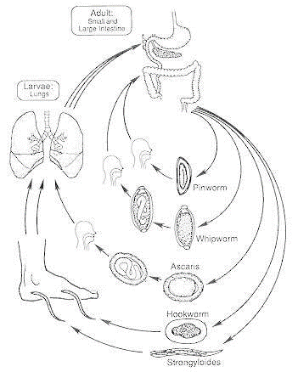
Figure 2.1 Lifecycle and stages in nematode development involving egg, larval and adult stages that facilitate transmission to the host and to the environment. (Adapted from (Castro, 1996))
Several intestinal helminths nematode developmental process involves egg, larvae and adult worm stages (Figure 2.1). The larval stage has four developmental stages and at the end of each stage moulting occurs whereby the cuticle is shed. The nematode formed at the fifth stage is the adult. The adult worm infects the definitive host where the sexual reproduction of the worm occurs. The larval stages are free living. The adult female nematodes lay eggs which are passed in feaces into the environment. The eggs hatch producing first larval stage L1 that undergoes several metamorphosis to L2, L3 and L4 immature adults. The final moult releases the premature adult which then matures into an adult worm. The male and the female adults mates and the female lays eggs completing the lifecycle (Wharton, 1986).
A study conducted in Kibale forest Uganda on NHPs showed that the colobus monkeys had a high prevalence of Trichuris spp the second prevalent parasite being the strongyloides where the NHPs are known to be the common reservoirs of the Strongyloides fuellerboni (Kouassi et al., 2015). Trichuris spp, strongyloides spp and Ancyclostoma spp have been found to be abundant nematodes in captive NHPs which is evident in a study conducted in Cameroon on wild and pet monkeys (Pourrut et al., 2011) From the similar study Trichuris spp was noted to be the most prevalent nematode at 12.9% which was in agreement with previous studies done by (Munene et al.,1998) and (Gery et al., 2020). Worms of Trichuris spp have been found to be common parasites of Baboons and Tantalus monkeys (Appleton et al., 1994).
Hookworm infections including Necator americanas and Ancyclostoma duodenale are transmitted transcutaneously by infective larvae and are abundant gastrointestinal parasites in the GIT of the monkeys while the Toxocara spp and Enterobius spp have been found to be the least prevalent (Kurpiers et al., 2015). A study that was done revealed a pet monkey (Erythrocebus patas) in Gombe Tanzania that had been trans located from Cameroon was found to have Schistosoma mansoni where the parasite is endemic and the explanation was this monkey probably got infected in Cameroon where the parasite is endemic and since it requires an intermediate snail host to complete the lifecycle the monkey must have acquired it while looking for drinking water probably in ponds. This findings have supported the arguments in the potential roles of primates in transmission and maintenance of schistosomiasis (Müller-Graf et al., 1996)
A study conducted in Amboseli ecosystem, Kenya, assessed parasite diversity in a sympatric host community that includes livestock and wild ungulates and NHPs (Obanda et al., 2019a). The study revealed dynamic host-parasite interaction characterized by parasite sharing among host species, while also being restricted by host phylogenetic background. Furthermore, the study revealed that there was parasitic richness in the NHPs proceeded by livestock and the least was the free-ranging ungulates. Among a few helminths identified were the Trichuris Trichuria, Strongloides spp, Oesophagostomum bificum, Trichostrongylus spp and Enterobius spp. Among the NHPs, findings illustrated that baboons and vervet monkeys jointly held four different species of helminths Primasubulura spp, Enterobius spp, Trichuris spp and Spirurina spp. The phylogenetic relatedness shared in geographic proximity among the NHPs and people inhabiting the Amboseli ecosystem poses a risk of cross species spill-over. Most of the species found in the NHPs were Trichuris spp, T.colubriformis, Enterobius spp, O.bifurcum, S.stercolaris and S.fuellerboni. All these are zoonotic parasites and present a risk of transmission to the pastoralist communities (Obanda et al., 2019b). From another study done in Kenya on potentially zoonotic GIT parasites coinfecting free ranging NHPs in the Kenyan urban centers of Mombasa, Kisumu, Muranga and Kakamega, research showed that, the number of nematode infections in NHPs was high in Mombasa, Kisumu and Kakamega and was least in Muranga. NHPs species sampled included the Red-tailed monkeys, African Green monkeys, Olive baboons and Blue monkeys. Coinfections were observed across the sampling sites in various NHPs the commonest being the Trichuris and Strongyloide spp. Strongyloide and Oesophagostomum coinfection was observed in 4.7% of the NHPs except in the African Green Monkeys. Coinfection with three nematodes was observed in all the NHPs except the Red-tailed monkeys but absent in the NHPs trapped in Kisumu and Muranga. Coinfection with four nematode species was observed in 8.1% of the NHPs. The study also showed mixed infections with two Oesophagostomum species occurred in 11 NHPs (Mbuthia et al., 2021a).
Helminthic infestation has been considered to be high compared to protozoan infection and this has been thought to be due to the favorable climatic conditions which provide optimal conditions for viability of the parasites eggs and ova (Longstaffe et al., 1984). It is paramount to maintain proper hygiene in order to minimize helminthic infections although by extension of hygienic hypothesis, some studies have postulated that low exposure of helminthic infections poses a higher risk of allergic and autoimmune diseases since helminthic infection trigger production of anti-inflammatory cytokines whereas allergic and autoimmune infections trigger pro-inflammatory cytokines (Yazdanbakhsh et al., 2002) and some studies have therefore postulated that administration of helminths can down modulate autoimmune and allergic inflammation although this is not the case in all helminthes since some studies have shown that ascariasis infection trigger the onset of asthma and asthma is a condition triggered due to allergic reactions (Wilson & Maizels et al., 2004). On the other hand, clearance of the helminthic infections can result in a resurgence of these diseases and understanding the helminths-induced immune regulatory mechanisms that control certain inflammatory diseases might point the way towards future treatments for these increasingly common immune disorders. (Fallon & Mangan et al., 2007).
During a helminthic infection, the preventive immune reaction against many helminths parasites has been diversely referred to as the type 2 immune response. This particular immune signal is referred to as T_{H}2 (T helper 2) response since it involves interaction between both the adaptive and the innate immune responses. Th2 -type reaction is characterized by elevation in the levels of interleukin-4 (IL-4), IL-5, IL-9, IL-13 and IL-21 with the activation and expansion of CD4⁺ T_{H}2 cells, plasma cells secreting IgE, eosinophils, mast cells and basophils, all of which can produce several types of T_{H}2-type cytokine (Fallon et al., 2006). In contrast, interferon-γ (IFNγ)- which is dominant in T_{H}1-type responses are typically evoked by microbial infections, including bacteria and viruses. These responses are associated with increased numbers of T_{H}1 cells, cytotoxic CD8⁺ T cells, neutrophils and macrophages (Anderson et al., 2007)
Protozoan parasites are unicellular, nucleated organisms that lack cell wall and are neither animals, fungi nor plants. Some of the intestinal protozoans of public health concern that are pathogenic include Cyclospora cayetanensis, Isospora species, Cryptosporidium species, Entamoeba histolytica and Giardia duodenalis (J. Li et al., 2020). Protozoal diseases are spread in set ups where there is inadequate sanitation, these diseases cause severe opportunistic infections in immunocompromised patients (Omarova et al., 2018). Diverse groups of protozoa reside in the digestive system of organisms and the majority of these protozoa are non-disease causing co-inhabitant or result in non-severe infections (Sodeman et al., 1996). The gastrointestinal protozoa are transmitted through fecal oral route in cystic infective stage (Figure 2.2). Protozoans are dimorphic organisms and exist as both cyst and trophozoites. The cysts are infective, resistant and are passed in feaces while the trophozoites are motile, short-lived, active feeders and replicate (Yaeger et al., 1996).
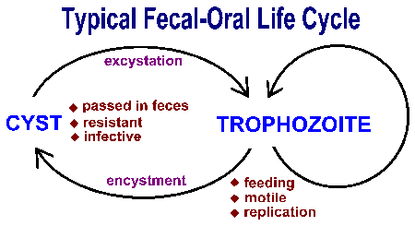
Figure 2.2 Transitioning of protozoan parasites from cystic stage to Trophozoite stage (Barratt et al., 2011)
Enteric protozoa are transmitted by ingestion of fecal contaminated matter and exhibit a life cycle with two key stages; the cyst and the propagative stage which is the trophozoite. Upon accidental ingestion of food contaminated with cysts, the cyst transforms into trophozoite which are motile and actively feeding. At this stage the parasite undergoes asexual replication. Instead of undergoing replication, some trophozoites will develop into cysts. Cysts are resistant and are excreted through feaces and when accidentally consumed again the life cycle begins once again (Barratt et al., 2011).
Infections with gastrointestinal parasites are widespread among the NHPs and with the consequence of regular deworming and hygienic measures, helminthic infections are uncommon among captive NHPs and on the contrary, protozoal infections such as Entamoeba histolytica, Cryptosporidium spp, Giardia spp and Balantidium spp are frequently reported in captive NHPs and have been known to cause gastrointestinal infections of medical importance which cause watery diarrhea, extra intestinal pathologies and dysentery and sometimes cause death (Silva et al., 2003; (Verweij, Oostvogel, et al., 2003). Giardiasis and cryptosporidiosis are of less clinical importance (Fayer & Xiao, 2007) whereas Entamoebiasis is of great health importance since it has been reported to cause major concerns and sometimes end up causing deaths during major outbreaks (Verweij, Vermeer, et al., 2003). In various studies, cross transmission between human and animals has been reported in animal caregivers and handlers hence the role of NHPs as potential reservoirs for zoonotic transmission should not be taken for granted in the Giardia, Cryptosporidium and Entamoeba transmission (Holmstrom et al., 2004).
In a study that was conducted on Gastrointestinal protozoa in NHPs of four zoological gardens in Belgium it was found that protozoa were most prevalent in captive and free ranging NHPs as it had been previously described in studies that had been done before on captive primates(Ali et al., 2008). In that particular study, the most prevalent parasite species was the Entamoeba spp and the Giardia spp and more than 40% of the species were infected with either of these endoparasites. The occurrence of this parasites can be explained with the fact that their life cycles do not require any intermediate hosts hence ease of transmission since they are infective upon transmission and on the other hand their low infective dose and short prepatent period obviously eases their transmission (Tanyuksel & Petri, 2003).
In most immunocompetent individuals, protozoal infections are clinically silent, but cause severe diseases in immune suppressed patients in particular with an impaired T cell and IFNγ response (Dupont et al., 2012). Protective immunity is typically achieved by inducing an IL-12-driven Th1 immune response (Scharton-Kersten et al., 1996). In a study done using a mouse model, IFN-I was already detected in the serum of T. gondii-infected animals during the acute phase (Figueiredo et al., 2019) IFN-I levels gradually increase with the progression of the infection. IFN-I was also detected in the brain and spleen of infected mice. These results demonstrate that T. gondii not only induces IFN-γ, but also IFN-I. (Matta et al., 2019). In the case of E. histolytica, it evades the host immune system through ways that are difficult to figure them out. Following the binding of E. histolytica to the reservoir cells, numerous cytotoxic outcomes occur that can foster cell death by means of phagocytosis and apoptosis, which might play critical roles in immune evasion (Begum et al., 2015).In Giardiasis, B cell-mediated antibody production and T cell-mediated immune responses play a critical in mounting defense mechanisms against Giardiasis. A study revealed that cellular immune response to Giardia has been well experimented and understood by use of murine models. The mice model showed that in the lack of CD4⁺ T cells, poor control or chronic infection to giardia occurs, indicating that these cells are crucial for the murine defense against G. lamblia (Dreesen et al., 2014). Studies have revealed that cytokines like tumor necrosis factor alpha (TNF-α) and gamma interferon (IFN-γ) are critical in informing the parasite load and the duration of an infection (Dann et al., 2015). Cytokines that are discharged by CD4⁺ T cells were found in the mice infected with Giardia, indicating that a range of T_{H} responses may contribute to the protection against Giardia (Dann et al., 2015).
In cryptosporidiosis, both innate and adaptive immune responses are important for controlling the disease. Innate immune responses are mediated by Toll-like receptor, antimicrobial peptides, prostaglandins, mannose-binding lectin, cytokines, and chemokines. (Laurent & Lacroix-Lamandé, 2017) Cell-mediated responses, especially those involving CD4⁺ T cells and IFN-γ, play a critical role. The parasite has however developed several evasion pathways to slow down these protective mechanisms and evade the immune system responses (Borad & Ward, 2010).

Table 2.1: Summary of Gastrointestinal parasite studies done on Non-human Primates in Kenya
Primate Species | Location | Detected parasites | Diagnostic Method/s used | Reference (study)
Baboons  Vervet monkeys | Amboseli Ecosystem | S.fuellerboni, S.stercoralis, T.colubriformis,O.bifurcum,Enterobius spp and Trichuris spp | Floatation, Sedimentation and Molecular techniques | (Obanda et al., 2019b)
Syke Monkeys, Black and white colobus, Debrazza monkeys, Mangabey monkeys, Olive baboons, Vervet monkeys |  | Strongloide spp, Schistosoma mansoni, Trichuris trichuria, Entamoeba spp, Balantidium and cryptosporidium | Acid fast staining, Wet fecal smears stained with iodine | (Munene et al., 1998a)
African Green monkeys, Olive baboons, Blue monkeys. Red tailed monkeys | Muranga, Kakamega, Kisumu, Mombasa | Oesophagostomum spp, Trichostrongylus colubriformis, Enterobius vermicularis, Trichuris spp, Ascariasis, Strongyloide spp | Microscopy,  PCR-HRM | (Mbuthia et al., 2021a)
Yellow baboons, Olive baboons | Amboseli national park, Mpala wildlife research | Oesophagostomum spp, Strongyloide spp, Trichuris spp, Streptopharagus spp, Physaloptera spp and Trichostrongylus spp | Formal ether, Sedimentation | (Hahn et al., 2003)

2.3 Factors that Influence GIT Parasite Transmission
The infective stage of most gastrointestinal parasites is dispersed to the environment from fecal deposition where both environmental and climatic conditions determine their propagation, persistence and transmission through fecal-oral route by the host. Transmission occurs as a result of resource sharing although the immune responses, genetic makeup and behavior of the host will determine the parasite establishment in the host (VanderWaal & Ezenwa, 2016)
There has been an increase in resources shrinkage resulting from shrinking habitat hence increasing the ranging and exploration rate that causes stress which in turn helps the endoparasites to multiply. Ectoparasites prevalence may increase during wet season and this may be the reason for higher ectoparasite infestation in bonnet macaques during dry season (Springer & Kappeler, 2016).
Contrasting patterns of seasonality in endoparasite prevalence have been reported among different primate species. For instance, a high prevalence of endoparasites was reported in five species of lemurs during the dry season (Bethge et al., 2023). However, because environmental moisture generally favors the survival and transmission of many endoparasites, prevalence is often expected to be higher during the wet season than during the dry season (Springer & Kappeler, 2016) whereas a high prevalence of endoparasites in the wet season has been reported in Pan troglodytes (Huffman et al., 1997) and Mandrillus sphinx (Setchell et al., 2007).
It has been noted that among different age and sex groups of primate species, females have a higher prevalence of endoparasites compared to males (Theron & Cloete, 2002). On the contrary, female bonnet macaque have been shown to have relatively high infections of protozoans only in the monsoon season and not in other seasons. Protozoans are waterborne and they multiply and persist during rainy season hence the infection prevalence is more during the monsoon season compared to the dry season. It is unclear that the infections of protozoans is higher in females than in other individuals (Theron & Cloete, 2002). A higher infection of endoparasites has been reported in Papio anubis and Macaca fuscata (Müller-Graf et al., 1996)

2.4 Diagnosis and Treatment
Microscopic examination remains a key diagnostic tool for the detection of helminths and protozoal infections. Both conventional and advanced diagnostic techniques have been employed towards NHP emerging parasitic disease surveillance in Kenya. These techniques have varied specificity and sensitivity and associations of both advantages and limitations. Microscopy and microbial cultures are the commonest methods used for diagnosis (Manchaiah et al., 2019). Microscopy is the most efficient diagnostic tool that has been utilized by researchers. It is the cheapest and convenient method of diagnosis since its consumables are readily available although it is time consuming and requires trained expertise (Berzosa et al., 2018a). During the diagnosis of gastrointestinal helminthes and protozoa, several microscopic techniques can be utilized this include the formal ether concentration technique, sedimentation technique and floatation technique. In formal ether concentration technique which involves the use of iodine stain, the method is favorable to protozoan cysts since the iodine stains the nuclear of the cysts making it visible under the microscope (Sapero & Lawless, 1953).
The spontaneous sedimentation technique uses the separation between solid and liquid media of different densities for the detection of infectious agents in feces and urine samples. Detection of intestinal parasites is done by preparing a homogeneous mixture containing five grams of feces diluted in distilled water, followed by filtration of the fecal suspension and a 12-hour sedimentation or centrifugation can be used to speed up the procedure (Tello et al., 2012). The supernatant liquid is then decanted until the sediment containing the parasites is isolated. Sedimentation can be applied on a large scale by using parasitological kits like the coprotest. The demerits of sedimentation is the inability to separate debris and parasites resulting in dense slides filled with impurities (Gomes et al., 2004).
The flotation technique was developed by Bass to detect hookworm eggs (Melvin, 1974). The principle of the technique is based on the difference between the density of a specific flotation solution and that of parasitic structures such as eggs, helminthes larvae, and protozoan cysts and oocysts and the procedure utilizes the use of viscous sucrose solution which enables the light denser parasites to float on top of the solution. Recovery of light helminthes eggs in supernatants of fecal samples suspended in sodium chloride solution (NaCl, 1.20 g/mL) has also been reported in a research done by (Willis et al 1921). However, crystal formation in the fecal smear and plasmolysis of protozoa by osmotic pressure when exposed to the saturated solution of salt makes this technique inappropriate for the recovery of dense eggs and protozoa (Collender et al., 2015).
In the genus level identification, most researchers are forced to conduct additional diagnostic assays such as larval culture (P.S Gillespie, n.d.). Trophozoites are prepared in wet preps since iodine tend to distort and kill the parasitic trophozoite stages. Formal ether concentration technique is an appropriate method for the rest of the parasites and mainly favors the cysts of protozoa since they stain the nucleus of the cysts and provide clarity in the distinguishing characteristics. The string test (entro-test) may be useful for revealing trophozoites from duodenal canal (Hooshyar et al., 2019).
Antigen detection assays that are available for gastrointestinal parasites include EIAs, ELISAs, and direct fluorescent-antibody tests(Barbecho et al., 2018). Molecular methods are highly sensitive and specific compared to the conventional methods and this has been utilized in species characterization especially where there is morphological similarities. (Lebbad, 2010). The dimerits of molecular diagnosis is that it is expensive in terms of reagents costs, requires trained and skilled personnel and it is not suitable for routine diagnosis (Berzosa et al., 2018b).

2.5 Research Gap
Wildlife has been known to be essential reservoirs of pathogenic diseases transmissible to humans. Across the continents, zoonosis with wildlife hosts has been a major public health problem affecting humans and therefore calls for more attention to be drawn so as to address this problem. Due to the rapid change in the human and the non-human primate dynamic relationship as a result of shared habitats, NHPs have suffered the effects of forest loss and fragmentation and have been forced to live in human disturbed habitats such as farmlands, human settlements, forest fragments and isolated protected areas. Despite the presence of NHPs in most urban centers in Kenya, comprehensive studies on gastrointestinal parasites in a number of NHPs are scant. Species such as baboons (Papio anubis) and vervet monkeys (Chlorocebus sabaeus) have been well studied but little or no attention to some species like the mangabey monkeys (Cercocebus atys) debrazza monkeys (Cercopithecus neglectus) and the colobus monkeys (Colobus guereza) which live in close proximity to humans. Because NHPS are potential reservoirs of zoonotic parasites, routine surveillance and characterization of circulating pathogens is paramount. In addition, most studies have utilized only microscopy screening and the research focused on performing gastrointestinal parasite screening and characterization among the understudied NHPs. Molecular screening and characterization is vital since it is highly sensitive and specific and genomic sequencing and molecular profiling provides leads on parasite species and host specificity.

CHAPTER THREE

MATERIALS AND METHODS

3.1 Study Site
The study was conducted at three sampling sites, the Tana River Primate National Reserve in Tana River County, Mathew Ranges in Samburu County and Kitale Museums Forest in Trans Nzoia County (Figure 3.1) between March – August 2021. These regions provide a favorable habitat for primates due to their dense forests, rich plant diversity and high human-nonhuman primate interface making the sites suitable for this study. Tana River Primate National Reserve, 1.5° S latitude and 40.5° E longitude, has an annual rainfall of 400-600mm and temperatures of 40-60°C. The region is also prone to flooding challenges due to the upstream rainfall and Tana River overflow facilitating the mobilization of waterborne and foodborne gastrointestinal parasites. Trans Nzoia County, 0.5° N latitude and 34.9°8 E longitude, has an average annual rainfall intensity of 1275 mm, average annual temperatures of 20.5°C. The region accommodates a huge junk of intense forests accommodating the livelihood of a variety of the NHP species. Mathews Range 1.19724° N Latitude and 37.35° E Longitude with a rainfall intensity of between 750mm and 1250mm per year is a region that favors occupation of a huge range of the Non-human Primate species. This region provided a rich ecological gradient that supported this study.
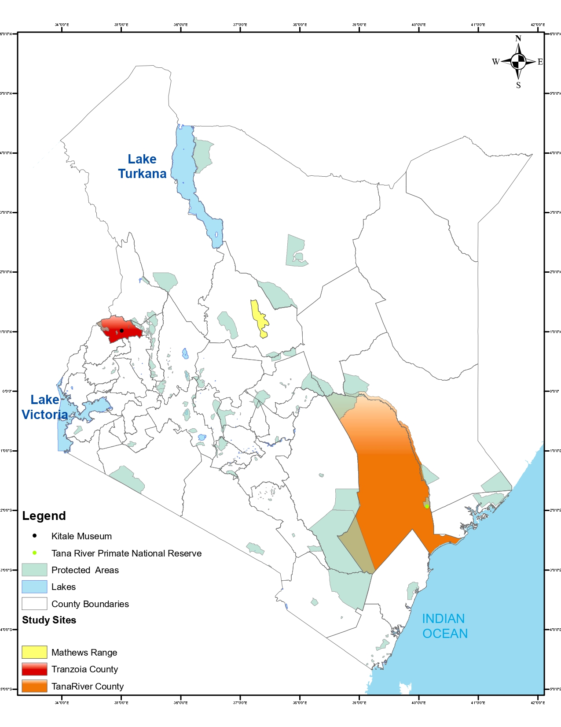
Figure 3.1: Map of Kenya showing counties of sample collection of study species of the Non-Human Primates Source: (ArcGIS Pro).

3.2 Study Population
The study focused on five NHP species from three Kenyan counties. These included the lower Tana River Syke monkey (Cercopithecus mitis ssp. Albotorquatus), which is a frugivorous and arboreal species to whom majority of ecological and behavioral studies have been conducted. The species is implicated in crop raiding and forms poly specific associations with the Tana River Red Colobus (Piliocolobus rufomitratus), Tana River Mangabey (Cercocebus galeritus), and occasionally with yellow baboons. The study also focused on Tana River Red Colobus (Piliocolobus rufomitratus) and the Tana River Mangabey (Cercocebus galeritus) who are both sympatric and florivorous while the latter is a fruit-seed eating primate species. While the Red colobus is mainly arboreal the Mangabeys are semi-terrestrials, both species interact with local people within their natural habitats in the gallery forests in lower Tana River (Mbora et al 2009). The two species utilize leaves or fruits that are high energy metabolites. (Kivai 2018) and this coupled with their behavioral attributes increases the species exposure to parasitic infections (Mbora et al., 2009 ). Both the Tana River Red Colobus and Tana River Mangabey are classified as endangered species.
In Trans Nzoia and Samburu Counties, two NHP species were sampled; the Black and white Colobus (Colobus guereza) and Debrazza Monkey (Cercopithecus neglectus), both inhabit the riparian forests in dense canopies near rivers and swamps (McDonald 2010). The Colobus spend 60% of their time resting and 40% socializing and feeding on young leaves where they supplement their diet with flowers, fruits and seeds (Chirchir et al 2018). Debrazza’s monkeys (Cercopithecus neglectus), considered as highly territorial NHPs and rarely associate with other NHP species. They store food in the cheek pouches and feed on flowers, leaves, seeds, seasonal fruits and feed on termites and beetles(Ej, 1985) making them vulnerable to gastrointestinal infections.
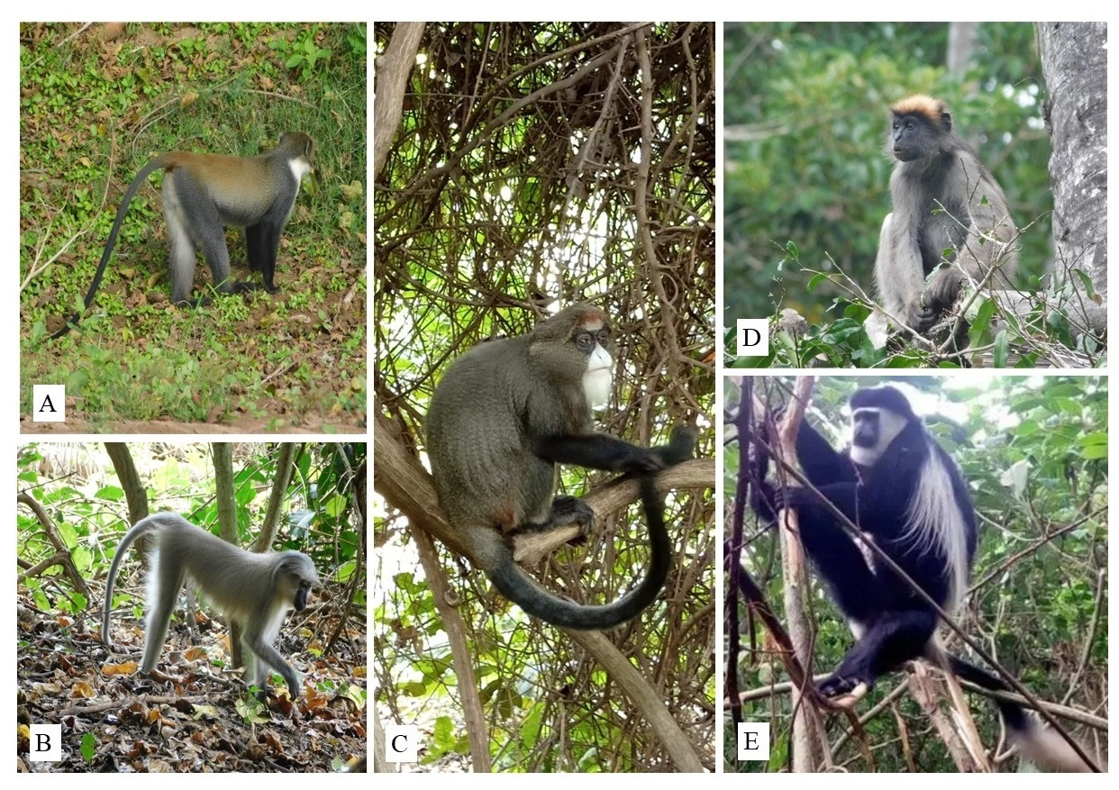
Figure 3.2: Selected Non-Human Primates sampled. A- Tana River Syke, B- Tana River Mangabey, C- De Brazza Monkey, D- Tana River Red Colobus and E- Black and White Colobus Source (Author’s photograph 2025).

3.3 Study Design, Sample Collection and Distribution
This study was conducted in two phases; field sample collection from all the study sites and laboratory analysis at the animal sciences department at the Kenya Institute of Primate Research. Fecal samples were collected during focal individual and group follows targeting habituated or semi-habituated groups from March to August 2021((Altmann, 1974);Clark 2011). Fresh fecal samples were collected non-invasively and opportunistically when an individual was observed defecating. Upon locating the dropped feces, approximately 15g of fresh fecal samples was scooped from the center to avoid soil and vegetation contamination using a sterile spatula and transferred to a 50ml container containing 10% formalin for microscopic analysis and another 15g of fresh fecal sample to a 50ml container containing 80% ethanol for molecular assays. The information recorded on the fecal sample label and in the data collection sheet included date of collection, species identity, age and sex of individual whenever possible, GPS location of the sample, habitat and the sample collector identity. However, there were instances where the observer could not identify the animal age-sex class especially in the semi-habituated groups due to high observer-animal physical distance. However, care was taken to avoid repeated sampling of a single individual using positive identification marks or traits such as unique marks, facial distinguishing features, and animal age-sex class besides other distinguishing characteristic of the individuals in the groups. The samples were then store properly at room temperature at the base camps before they were transferred to the laboratory for parasitology analysis.
A total of 148 fecal samples were collected from the NHPs from the three study sites. Tana River County had a total of 60 fecal samples, which included Tana River Mangabey monkeys (30), Tana River Red Colobus monkeys (19) and Tana River Syke monkeys (11). Trans Nzoia County had a total of 49 fecal samples from De Brazza’s monkeys (24) and Mau Forest black and white Colobus (25). Samburu County had a total of 39 fecal samples which included Debrazza monkeys (17) and Black and white colobus (22).
Table 3.2: Sample Size Distribution of Understudied Non-Human Primates (NHPs) Across Three Counties
County | Syke Monkey | Mangabey Monkey | Red Colobus | De Brazza Monkey | Black & White Colobus | Total
Tana River County | 11 | 30 | 19 | - | - | 60(40.5%)
Trans Nzoia County | - | - | - | 24 | 25 | 49(33.1%)
Samburu County | - | - | - | 17 | 22 | 39(26.4%)
Total | 11(7.4%) | 30(20.4%) | 19(12.9%) | 41(27.9%) | 47(32.0%) | 148

3.4 Microscopic Screening Techniques

3.4.1 Fecal Parasitology
Microscopic analysis utilized the formal ether, sedimentation and floatation techniques.
a) Formal-Ether Concentration Technique
Fecal samples preserved in 10% Formalin were used for this technique. Three grams of fecal sample was place in a beaker and 10% formalin added and thoroughly mixed, 7 ml was then transferred into a 15 ml tube through a tea strainer so as to get rid of the debris and 3ml of diethyl ether was added to fill it to 10ml followed by centrifugation at 500rpm/10minutes (Blagg et al., 1955). After spinning, the supernatant was cast off, a drop of the pellet put on a clean labelled microscopic slide, a drop of iodine added to the sample and a coverslip mounted on top then observed under X10 objective lens.
b) Sugar-Floatation Technique
To perform the sugar floatation technique, 3 g of fecal sample preserved in formalin was emulsified in distilled water and passed through a tea strainer. This was followed by the transfer of 12ml of the mixture into a 15ml tube and spanned at 500rpm for 10 minutes. The supernatant was discharged and 3ml of the sugar solution added into the tube and vortexed. The tube was then filled completely and covered with a coverslip and spanned at 1000rpm for 10 minutes. The cover slip was carefully transferred onto the microscopic slide and observed under X10 objective lens.
c) Sedimentation Technique
The fecal specimen was emulsified in distilled water and passed through a tea strainer. A volume amounting to 12 ml of the fecal and water mixture was transferred into the 15 ml tube and spanned at 500rpm for 10minutes. The supernatant was discarded and pellet observed under X 10 objective lens.

3.4.2 Molecular Screening
Fecal samples preserved in 80% ethanol were used for molecular assays. DNA extraction was performed using the QIAamp DNA stool minikit, involving sample homogenization, centrifugation, and buffer treatment. The extracted DNA was quantified via nanodrop UV absorbance. PCR of the target regions was carried out in 12.5 ul reactions containing 2 ul of genomic DNA, 1.0 ul of the Forward primer, 1.0 ul of the reverse primer, 2.25 ul of the nuclease free water and 6.25 ul of One Taq.
The first-round polymerase chain reaction (PCR) for the Trichuris primers External ITS1_Trichuris-1417 forward primer sequence (5’-AGGGACCAGCGACACTTTC-3’) and ExternalITS1_Trichuris-2505 reverse primer sequence (5’-GAGTGTC ACGT CGTTCTTCAAC-3’) was used. The thermal cycling PCR conditions used were 95°C for 3 min; 35 cycles of 95°C for 30 s, 61°C for 30 s, 72°C for 1 min, and a last extension at 72°C for 10 min. The nested PCR utilized InternalITS1_Trichuris-1567 forward primer with sequence (5’-GTTCTCGTGACTGGGAC-3’) and InternalITS1_Trichuris-2462 reverse primer of base sequence (5’-CTACGAGCCAAGTGATCC-3’) with PCR settings of 95°C for 3 mins, followed by 35 cycles of 95°C for 30 s, 55°C for 30 s, 72°C for 1 min, and the last extension at 72°C for 10 mins. The anticipated target amplicons are an estimated 1088bp for the primary PCR and 895 bp for the secondary PCR.
The universal nematode primer screening NC2 (59TTAGTTTCTTTTCCTCCGCT-39) and NC5 (59-GTAGGTGAACCTGCGGAAGGATCATT-39 was used to amplify the rDNA from the ITS region; (Newton et al., 1998). With PCR settings initial denaturation of 95°C for 3 mins, second denaturation at 95°C for 30secs, 40 cycles of 57°C annealing temperature for 30secs, 72°C for 1min extension and the last extension at 72°C for 5 min. The expected band size was 865bp.
The nested PCR primers used for Entamoeba screening included; Entam 1F for Round 1& 2 (5’GTTGATCCTGCCAGTATTATATG3’), Entam2_R2 (5’CACTATTGGAGCTGGAATTAC3’), and Entam5_R1 (5’CRACTACGAGCKTTTTAAWCAC3’) (Verweij et al. 2003). Amplification proceeded by a 10 minutes polymerase activation step at 95°C with 35 cycles of 1 minute each at 57°C annealing, 72°C extension, and 95°C denaturation temperature. The cycles followed a 5 minutes extension temperature of 72°C. For both loci, amplification was detected using agarose gel Electrophoresis. Summary of Parasite targets and primers are shown in Table 3.2.
Table 3.2: Parasite Target and Primers
Parasite target | Primer name | Target/ Expected Band size
Universal Nematode primers | NC2 forward | ITS1
Universal Nematode primers | NC5 reverse | ITS1 (865bp)
Trichuris | External_Trichuris-1417F | ITS1_Trichuris
Trichuris | ExternalITS1_Trichuris-2505R
Trichuris | Internal_Trichuris-1567F | ITS1_Trichuris(895bp)
Trichuris | InternalITS1_Trichuris-2462R
Entamoeba | Entam1_F | SSU rDNA
Entamoeba | Entam2_R2
Entamoeba | Entam5_R1 | (650bp)

3.4.3 Sequencing Analysis of Entamoeba Spp.
A total of 14 positive samples based on brighter band appearance on gel electrophoresis were selected for sequencing with a representation from each NHP species and purified using Exo-sap PCR clean-up kit Bi-directional capillary sequencing was done at the International Livestock Research Institute (ILRI, Kenya) using an ABI 3730xl capillary sequencer (Applied Biosystems). Consensus sequences from the sequencing data were created using the forward and reverse sequences using Bioedit version 7.2.5 software (Hall, 1999). The sequences were searched against NCBI https://www.ncbi.nlm.nih.gov/) using BLASTn. For species identification, a homology cut off of 93% - 100% identity with a GenBank E-value threshold of 1e-123 was used. Sequences generated from this study and ITS2 ribosomal sequences retrieved from GenBank using accession numbers FR686376.1, MT734620.1, FR686376.1, MW026788.1 and FR686371.1 were used in the construction of the maximum likelihood phylogenetic tree inferring to the evolutionary history in MEGA7 (Kumar et al., 2018) with bootstrapping at 100 replicates.

3.5 Statistical Analysis
Data were analysed using R statistical software through RStudio version 2024.12.0+467 “Kousa Dogwood”. Descriptive statistics were used to summarize parasite prevalence, parasite richness, co-infection patterns and diagnostic test performance. Parasite prevalence was calculated as the proportion of sampled non-human primates positive for each parasite taxon and was expressed as percentages with 95% confidence intervals where appropriate.
Associations between parasite prevalence and categorical variables such as sampling location and non-human primate species were assessed using Chi-square tests. Fisher’s exact test was used where expected cell counts were small. Co-infection status was categorized as no infection, single infection or co-infection, and differences in co-infection burden across locations and host species were assessed using Chi-square tests or Fisher’s exact tests where appropriate. Parasite richness was defined as the number of parasite taxa detected per individual sample. Because richness data were count-based and not assumed to be normally distributed, differences in parasite richness across sampling locations and host species were assessed using the Kruskal–Wallis test. Where pairwise comparisons were required, Wilcoxon rank-sum tests were used.
Diagnostic performance of microscopy relative to PCR was assessed for selected parasite targets. Sensitivity, specificity, positive predictive value, negative predictive value and overall accuracy were calculated using PCR as the reference method. The consensus between conventional microscopy and PCR was assessed using Cohen’s kappa statistic, while differences in paired positivity between the two diagnostic methods were evaluated using McNemar’s test. Statistical significance was assessed at p < 0.05.
Sequence data were edited and curated using BioEdit version 7.2.5 (Hall T.A, 1999). Parasite sequence identity was assessed using NCBI BLASTn searches against reference sequences in GenBank. Multiple sequence alignment and phylogenetic reconstruction were performed using MEGA version 11.0.13 (Kumar et al., 2018). Phylogenetic tree reliability was evaluated using bootstrap analysis with 1,000 replicates.

3.6 Ethical Considerations
Institutional approval was issued by the Kenya Institute of Primate Research’s Institutional Scientific Ethics and Review Committee (ISERC) for the purpose of ethical approvals on the use of animal models to conduct research, of approval number (ISERC/04/2021) and Wildlife Research Training Institute (WRTI) permits number (KWS/BRP/50001).

CHAPTER FOUR

RESULTS

4.1 Microscopic Examination of Zoonotic Gastrointestinal Parasites
Microscopic examination revealed 11 gastrointestinal helminths and protozoa (Figure 4.1) which were identified based on morphological features. The Ascariasis spp egg had a brownish to yellow appearance in color with round oval shape of 45-75 um long and 35-50um width in size and a thick shell with 3 layers, while Trichuris spp eggs were barrel shaped, brown to yellow brown in color with 2 polar plugs at both ends with characteristic features. The Balantidium cyst was marked by its spherical to ovoid shape with approximately 40-60um in diameter, thick wall with kidney-shaped macronucleus whereas the trophozoite was oval and elongated with 50-200um in diameter with visible ciliates on the surface. Strongyle egg was identified to be slightly colorless to grayish in color with ovoid in shape with a thin and smooth shell. The Strongyloide larvae was marked with a slender elongated body of approximately 180-380um length with a sharp pointed tail and short buccal cavity. Entamoeba spp cyst appeared as round and spherical with smooth and well-defined cyst wall with 1-4 nuclei.

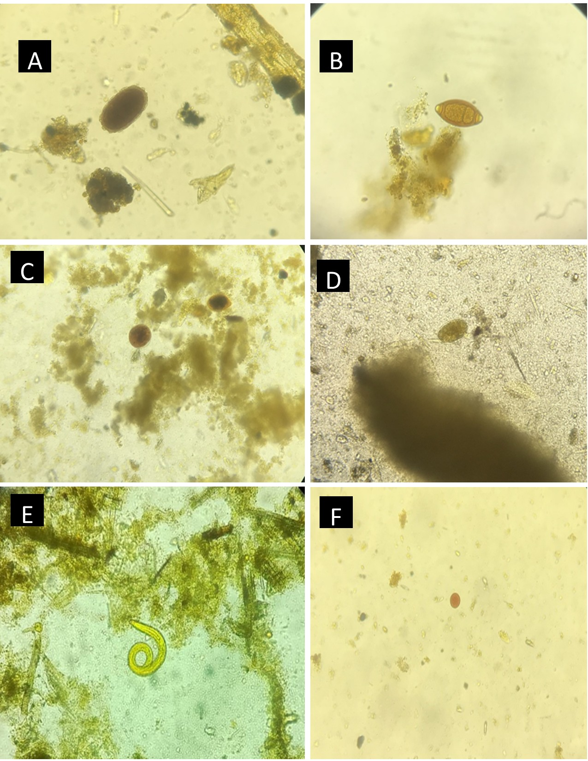
Figure 4.1: Parasites identified via microscopic examination. (A) Ascariasis spp egg (B) Trichuris spp egg (C) Balantidium cyst and trophozoite (D) Strongyle egg (E) Strongyloide larvae (F) Entamoeba spp.
4.2 Gastrointestinal parasite prevalence across taxa and geographical locations
Parasite prevalence was defined as the proportion of sampled non-human primates in which each gastrointestinal parasite taxon was detected. Prevalence was summarized as frequencies and percentages, with 95% confidence intervals where applicable. Differences in parasite prevalence across sampling locations and host taxa were assessed using Chi-square tests or Fisher’s exact tests when expected cell counts were small.
Entamoeba was the most prevalent parasite (71.6%), followed by Balantidium (31.8%), whereas Strongyloides (16.9%), Eimeria (12.8%) and Trichuris (11.5%) showed moderate prevalence (Figure 4.2A). The remaining parasite taxa occurred at relatively low frequencies, including Abbreviata (10.1%), Streptopharagus (8.8%), soil nematodes (4.7%), Oesophagostomum (4.7%) and E. vermicularis (3.4%). Ascaris spp. was the rarest detected parasite, with an overall prevalence of 0.7%. Parasite prevalence differed across study locations. Entamoeba was dominant at all three sites (Figure 4.2B)., with the highest prevalence observed in Tana River (78.3%) and Trans Nzoia (75.5%), and a comparatively lower prevalence in Samburu (56.4%). This location-associated difference in Entamoeba prevalence was statistically significant, χ² = 6.13, p = 0.047. Balantidium showed a stronger site-specific pattern, with markedly higher prevalence in Trans Nzoia (65.3%) than in Tana River (18.3%) or Samburu (10.3%), χ² = 38.76, p < 0.001. Other parasites also differed significantly by location, including Strongyloides (χ² = 9.80, p = 0.007), Eimeria (χ² = 6.20, p = 0.045), Trichuris (χ² = 10.31, p = 0.006), soil nematodes (χ² = 20.54, p < 0.001), Abbreviata (χ² = 16.04, p < 0.001) and Oesophagostomum (χ² = 6.42, p = 0.040). These findings indicate that parasite assemblages differed across study sites both in overall prevalence and in taxonomic composition. Host-associated differences in parasite prevalence were also observed. Entamoeba remained the most prevalent parasite across all sampled primate taxa (Figure 4.2C)., with the highest prevalence recorded in Mangabey monkeys (90.0%), followed by De Brazza’s monkeys (75.6%), Sykes monkeys (72.7%), red colobus (63.2%) and black-and-white colobus (59.6%). However, the difference in Entamoeba prevalence across host species was borderline and did not reach conventional statistical significance, χ² = 9.34, p = 0.053. Balantidium prevalence differed significantly across host species, χ² = 12.16, p = 0.016, being highest in De Brazza’s monkeys (46.3%) and black-and-white colobus (36.2%). Trichuris also varied significantly by host species, χ² = 21.85, p < 0.001, with the highest prevalence observed in Sykes monkeys (45.5%), followed by Mangabey monkeys (23.3%). Streptopharagus, soil nematodes, Abbreviata and Oesophagostomum also showed significant host-associated variation, all with p < 0.001. Overall parasite occurrence also differed by both location and host taxon. The proportion of individuals with at least one detected parasite differed significantly across locations, χ² = 6.42, p = 0.040, and across host species, χ² = 13.66, p = 0.008. Together, these findings show that gastrointestinal parasite prevalence was structured by both geography and host taxon, although rare parasite taxa should be interpreted cautiously because low event counts produce wider confidence intervals and greater uncertainty.

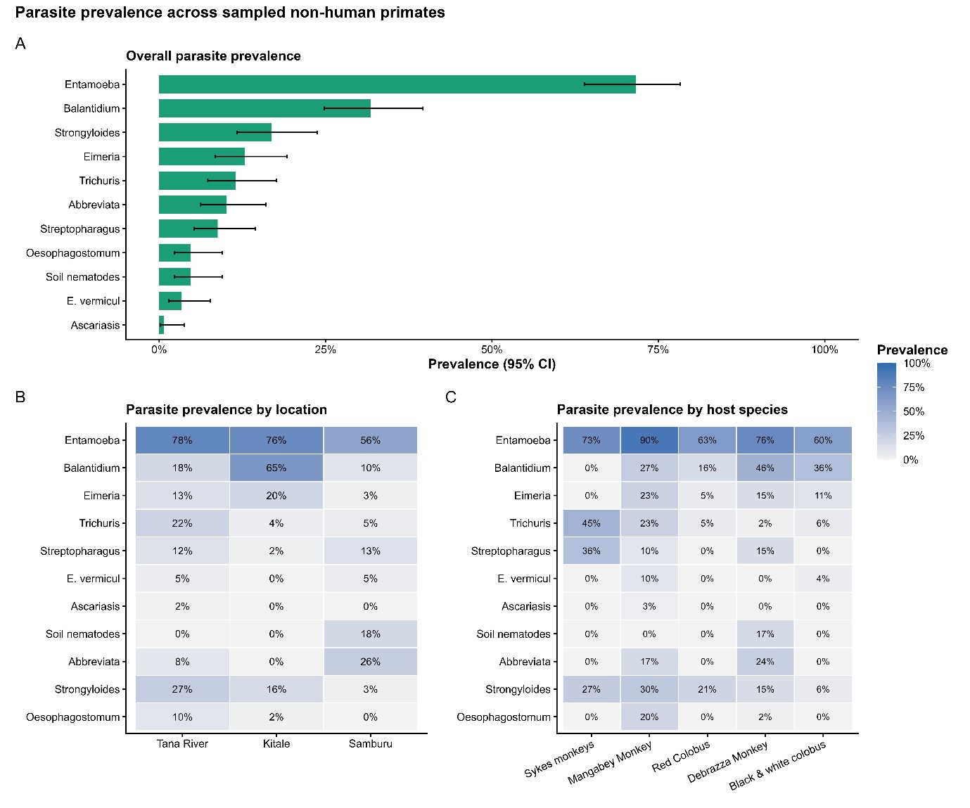
Figure 4.2: Bars representing the estimated parasite prevalence across sampled non-human primates. (A) Overall prevalence of detected parasite taxa, with error bars indicating 95% confidence intervals. (B) Heatmap showing parasite prevalence across study locations. (C) Heatmap showing parasite prevalence across host species. Darker shading indicates higher prevalence. Together, the panels show the overall distribution of parasite taxa and highlight spatial and host-associated variation in parasite occurrence.

4.3 Parasite richness and co-infection burden across locations and host species
Parasite richness (Figure 4.3) was defined as the number of parasite taxa detected in each individual primate sample. Richness was calculated as total parasite richness and was also separated into protozoan richness and nematode richness. Total parasite richness ranged from 0 to 7 parasite taxa per host, with a mean richness of 1.77 parasite taxa and a median richness of 2. Protozoan richness ranged from 0 to 3 taxa, with a mean of 1.16 and a median of 1, while nematode richness ranged from 0 to 5 taxa, with a mean of 0.61 and a median of 0. These findings indicate that some individuals were parasite-negative, while others carried multiple parasite taxa.
Richness differed across study locations. Protozoan richness was significantly different across locations, Kruskal–Wallis H = 30.05, p < 0.001, and was highest in Trans Nzoia, where the mean protozoan richness was 1.61 (Figure 4.3A). Tana River had a mean protozoan richness of 1.10, while Samburu had the lowest mean protozoan richness of 0.69. Nematode richness also differed significantly across locations, H = 8.94, p = 0.011, with greater variability observed in Tana River. Total parasite richness showed a borderline difference across locations, H = 5.65, p = 0.059, with mean total richness of 1.95 in Tana River, 1.88 in Trans Nzoia and 1.36 in Samburu.
Parasite richness also differed across host species. Protozoan richness varied significantly by host species, H = 12.02, p = 0.017, while nematode richness showed stronger host-associated variation, H = 25.28, p < 0.001. Total parasite richness also differed significantly across host species, H = 27.49, p < 0.001. Mangabey monkeys had the highest mean total parasite richness (2.27) (Figure 4.3B), followed by De Brazza’s monkeys (2.20), Sykes monkeys (1.73), Black-and-white Colobus (1.34) and Red Colobus (1.26). These results suggest that parasite diversity varied across both ecological and host-associated strata.
Co-infection was defined as the detection of two or more parasite taxa in the same primate sample. Infection burden was classified into three groups: no infection, single infection and co-infection. Infection burden differed significantly across locations, χ² = 10.04, p = 0.040. Trans Nzoia showed the highest co-infection burden (Figure 4.3C), with 71.4% of samples harbouring two or more parasite taxa, compared with 53.3% in Tana River and 41.0% in Samburu. Parasite-negative samples were least common in Trans Nzoia (6.1%) and most common in Samburu (25.6%), with Tana River showing an intermediate proportion (18.3%). Single infections were observed in 22.4% of Trans Nzoia samples, 28.3% of Tana River samples and 33.3% of Samburu samples. These results indicate that parasite co-occurrence was greatest in Trans Nzoia, whereas Samburu had a comparatively lower overall infection burden.
Infection burden also differed significantly across host species, χ² = 30.24, p < 0.001. Co-infection was most common among De Brazza’s monkeys (82.9%) (Figure 4.3D), followed by Mangabey monkeys (70.0%), Sykes monkeys (45.5%), black-and-white colobus (36.2%) and red colobus (31.6%). In contrast, red colobus had the highest proportion of parasite-negative samples (36.8%), followed by black-and-white colobus (23.4%), Sykes monkeys (18.2%), Mangabey monkeys (6.7%) and De Brazza’s monkeys (4.9%). Single infections were most frequent among black-and-white colobus (40.4%) and least frequent among De Brazza’s monkeys (12.2%). Overall, these findings demonstrate significant host-associated heterogeneity in parasite accumulation and co-occurrence.

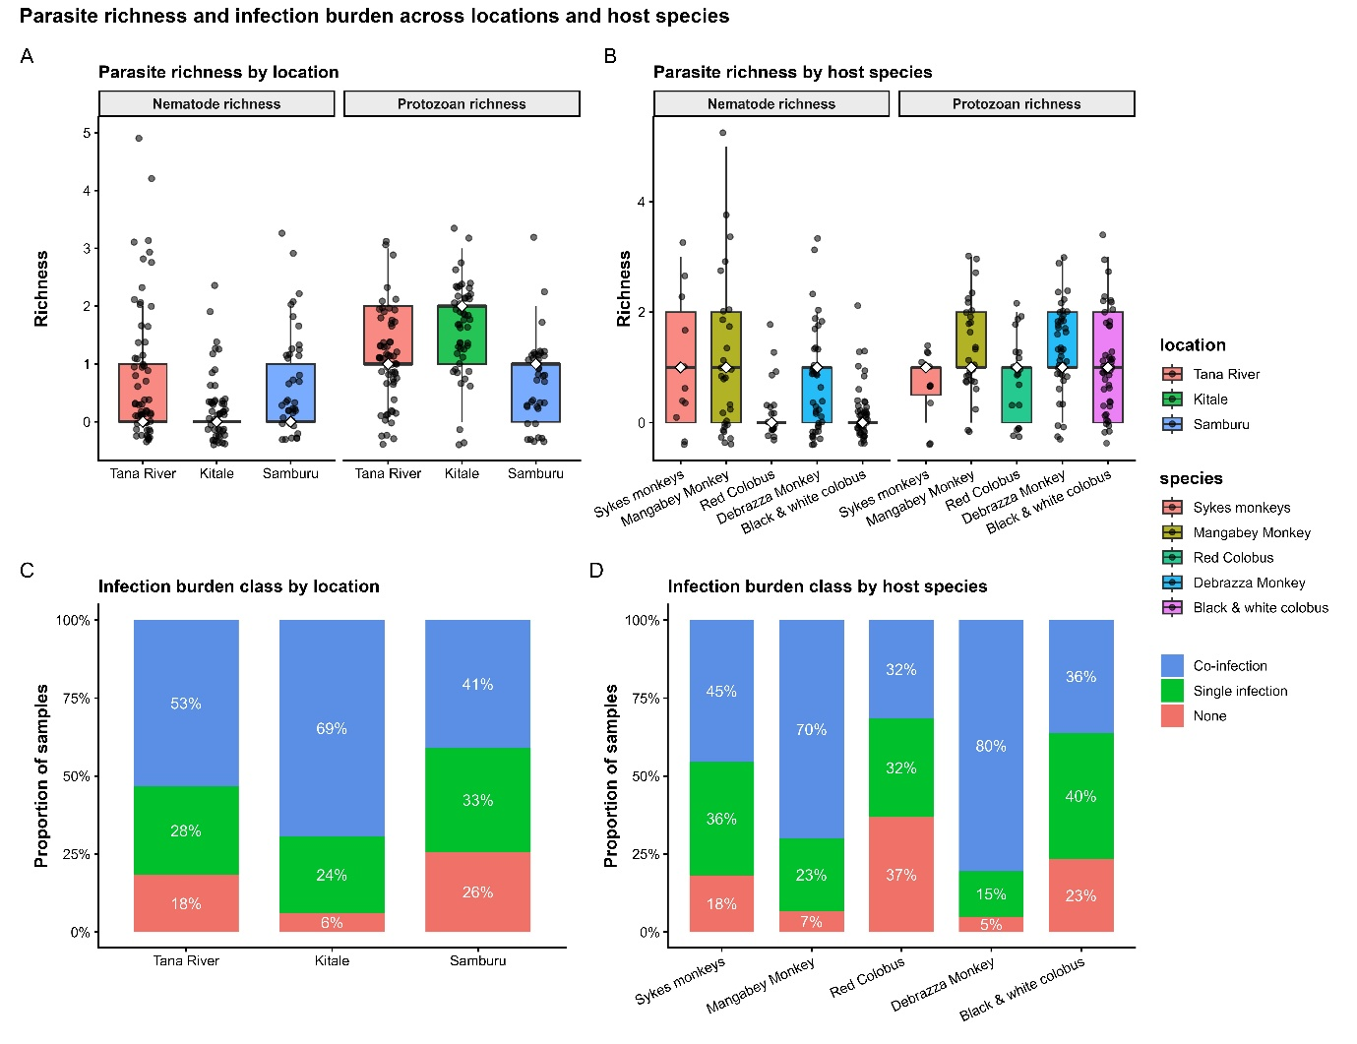
Figure 4.3: Parasite richness and infection burden across locations and host species. (A) Boxplot showing the distribution of nematode and protozoan richness across study locations. (B) Distribution of nematode and protozoan richness across host species. In the boxplots, the center line indicates the median, boxes represent the interquartile range, whiskers show the spread of the data and points represent individual samples. (C) Proportion of samples classified as no infection, single infection or co-infection across study locations. (D) Proportion of samples classified as no infection, single infection, or co-infection across host species. Together, these panels summarize variation in parasite diversity and the extent of parasite co-occurrence across ecological and host strata.

4.4 Molecular Screening of Parasite Species
Three parasites (nematode, Trichuris and Entamoeba) were screened among the 109 samples. Nematode was detected in 32 samples with expected band size of 865bp. Trichuris spp was reported in 4/109 with bands at 895bp while. Entamoeba species was identified in 81/109 with a band size at 650bp (Figure 4.4).

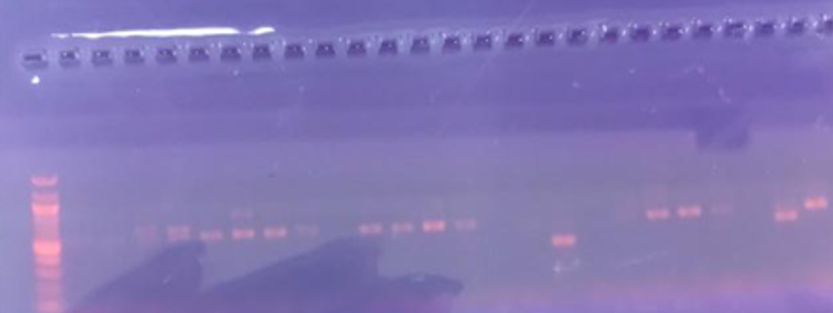


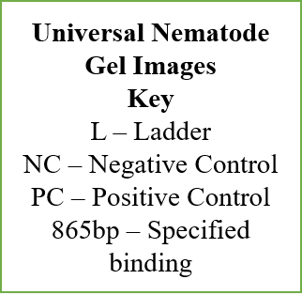
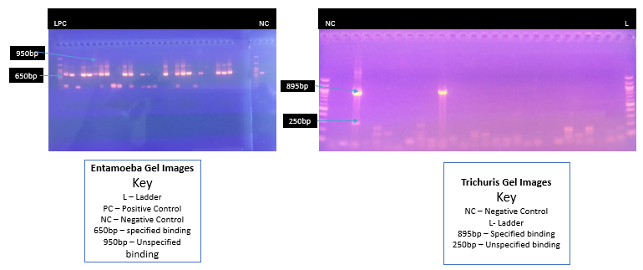

Figure 4.4: Molecular Identification of Parasites. (1). Universal Nematode gel image; expected band size 865bp, L-Ladder, NC- Negative control, PC- Positive control (2). Entamoeba gel image; expected band size is 650 bp, unspecified binding at 950bp, L- ladder, NC- Negative control. (3). Trichuris gel images; expected band size is 895bp and unspecified binding at 250bp. 4.2.2 Molecular identification and Phylogenetic Analysis of Entamoeba species
A total of 14/81 PCR positive samples were sequenced. Sequences were retrieved from 5 samples (De Brazza’s monkey (2), Black and white Colobus (1), Tana River Red colobus (1) and Tana River Sykes (1). The BLAST results identified E. hartmani and unidentified Entamoeba spp that was observed in the Syke monkeys as the best hit with percentage ID between 93.03% to 100% and low E-values (Table 4.1).

Table 4.1: BLAST results of amplified Entamoeba species against NCBI
Query | NPH Species | NCBI Best Hit | Accession Number | % ID | E Value
Entam 2E | De Brazza ‘s monkey | Entamoeba hartmani | FR686376.1 | 99.60% | 2e- 123
Entam 18E | Tana River Sykes monkey | Unidentified Entamoeba spp | MT734620.1 | 99.24% | 4e- 58
Entam 24E | Tana River Red Colobus | Entamoeba hartmani | FR686371.1 | 98.28% | 8e- 173
Entam 5E | Black and white Colobus | Entamoeba hartmani | FR686376.1 | 93.05% | 4e- 166
Entam 15E | De Brazza’s monkey | Entamoeba hartmani | MW026788.1 | 95.68% | 8e- 57

Phylogenetic analysis revealed four distinct Entamoeba clades (Figure 4.5). The species derived from the De Brazza species formed a distinct cluster. Further, the species retrieved from the Mau Forest black and white colobus, Red colobus and De Brazza clustered together with variants that have previously been reported in human and baboon samples (Papio anubis). The sequences from the Syke monkey clustered with the Yak associated sample. E. coli was utilized as the outgroup clade in the analysis.

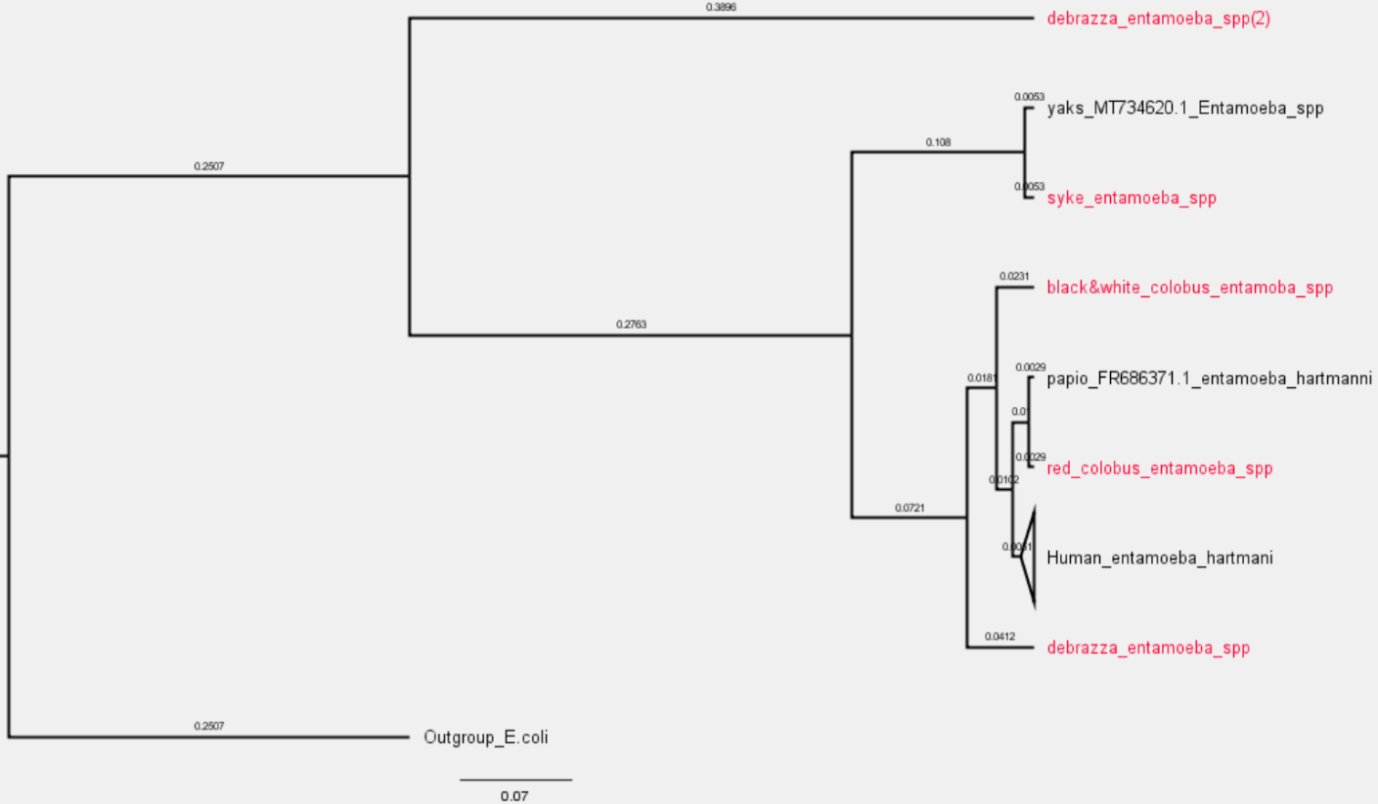

Figure 4.5: Phylogenetic tree of Entamoeba identified in NHPs. Sequences obtained from NCBI are indicated by their accession numbers. Percentage bootstrap supports (1000 replicates) are shown by numbers at the respective nodes.

4.5 Sensitivity and Specificity of Diagnostic Tests

4.5.1 Microscopy vs PCR Detection of Entamoeba
For Entamoeba, both microscopy and PCR identified a high proportion of positive samples (Figure 4.6), indicating that this organism was common in the study population. PCR detected approximately 74% of samples as positive, while microscopy detected about 71% (Figure 4.6A), showing only a modest difference in overall positivity between the two methods. When PCR was treated as the reference method, microscopy showed good sensitivity (81%), indicating that most PCR-positive Entamoeba infections were also detected by microscopy. However, specificity was lower (61%), showing that a proportion of microscopy-positive results were not confirmed by PCR. The positive predictive value (PPV), was high (86%), suggesting that microscopy-positive Entamoeba findings were often true positives relative to PCR. In contrast, the negative predictive value (NPV) was lower (53%) (Figure 4.6B), indicating that a negative microscopy result did not reliably exclude PCR positivity. Overall accuracy was 76%. The agreement matrix showed that the largest proportion of samples fell into the microscopy-positive and PCR-positive category (60.6%), followed by microscopy-negative and PCR-negative samples (15.6%). Discordant results were also observed, with 10.1% of samples classified as microscopy-positive/PCR-negative and 13.8% as microscopy-negative and PCR-positive (Figure 4.6C). This indicates that agreement between the two methods for Entamoeba was driven mainly by concordant positive detections, consistent with the high prevalence of the organism in the sampled hosts.
Figure 4.6: Diagnostic performance of microscopy relative to PCR for overall Entamoeba detection. (A) Overall proportion of samples classified as positive by microscopy and PCR. (B) Diagnostic performance estimates for microscopy using PCR as the reference method, including sensitivity, specificity, positive predictive value (PPV), negative predictive value (NPV) and accuracy. (C) Agreement matrix showing the number of samples classified as microscopy-negative and PCR-negative, microscopy-negative and PCR-positive, microscopy-positive and PCR-negative, and microscopy-positive and PCR-positive. (D) Distribution of microscopy-PCR agreement classes across study locations. Together, the panels show that microscopy detected more samples as positive than PCR, but exhibited limited agreement with PCR and substantial discordance, particularly through microscopy-positive and PCR-negative classifications.
Table 4.2: Microscopy–PCR 2 × 2 classification matrix for Entamoeba parasite detection
Microscopy result | PCR result | n
Negative | Negative | 17
Negative | Positive | 81
Positive | Negative | 77
Positive | Positive | 66
The agreement matrix indicated that 66 samples were positive by both microscopy and PCR (Table 4.2), whereas 17 were negative by both methods. In contrast, substantial discordance was observed, with 77 samples classified as microscopy-positive but PCR-negative and 81 classified as microscopy-negative but PCR-positive Diagnostic figure.

4.5.2 Microscopy vs PCR Detection in Nematodes
Microscopy detected more nematode samples as positive than PCR but exhibited limited agreement with PCR and substantial discordance, particularly through microscopy-positive and PCR-negative classifications (Figure 4.7). Overall, microscopy identified a higher proportion of samples as nematode positive than PCR, detecting approximately 34% of samples compared with 23% by PCR screening (Figure 4.7A). Using PCR as the reference, microscopy showed low sensitivity (28%), indicating that it failed to identify a large proportion of PCR-positive samples. Specificity was 64%, suggesting only moderate ability to correctly classify PCR-negative samples. The positive predictive value (19%) was low, meaning that relatively few microscopy-positive results were confirmed by PCR, whereas the negative predictive value (75%) (Figure 4.7B) was comparatively higher, indicating that microscopy-negative results were more reliable than microscopy-positive results in this dataset. Overall diagnostic accuracy was 56%, consistent with only modest agreement between the two methods Diagnostic figure. The agreement matrix showed that the largest proportion of samples fell into the microscopy-negative and PCR-negative category (49.5%), followed by microscopy-positive and PCR-negative samples (27.5%). Discordant results were also observed, with 16.5% of samples classified as microscopy-negative and PCR-positive and 6.4% as microscopy-positive and PCR-positive (Figure 4.7C).

Figure 4.7: Diagnostic performance of microscopy relative to PCR for overall nematode detection. (A) Overall proportion of samples classified as positive by microscopy and PCR. (B) Diagnostic performance estimates for microscopy using PCR as the reference method, including sensitivity, specificity, positive predictive value (PPV), negative predictive value (NPV) and accuracy. (C) Agreement matrix showing the number of samples classified as microscopy-negative and PCR-negative, microscopy-negative and PCR-positive, microscopy-positive and PCR-negative, and microscopy-positive and PCR-positive. (D) Distribution of microscopy-PCR agreement classes across study locations.

Table 4.3: Microscopy–PCR 2 × 2 classification matrix for nematode parasite detection
Microscopy result | PCR result | n
Negative | Negative | 54
Negative | Positive | 18
Positive | Negative | 30
Positive | Positive | 7
The agreement matrix indicated that 7 samples were positive by both microscopy and PCR (Table 4.3), whereas 54 were negative by both methods. In contrast, substantial discordance was observed, with 30 samples classified as microscopy-positive but PCR-negative and 18 classified as microscopy-negative but PCR-positive Diagnostic figure.

4.5.3 Microscopy vs PCR Detection of Trichuris
Overall positivity was much lower, and microscopy detected a substantially greater proportion of positives (16%) than PCR (4%) (Figure 4.8A), indicating stronger disagreement between the two methods for this parasite. Using PCR as the reference, microscopy showed moderate sensitivity (50%), meaning that only about half of PCR-positive samples were detected by microscopy for Trichuris. In contrast, specificity was high (85%), indicating that microscopy correctly classified most PCR-negative samples. The positive predictive value (PPV) was very low (11%), showing that only a small proportion of microscopy-positive Trichuris results were confirmed by PCR. By contrast, the negative predictive value (NPV) was very high (98%) (Figure 4.8B), indicating that microscopy-negative results were highly reliable for ruling out PCR-confirmed infection. Overall accuracy was 84%, although this was largely due to the high frequency of true negative samples. The agreement matrix showed that the dominant category was microscopy-negative and PCR-negative (81.7%), whereas microscopy-positive and PCR-negative samples accounted for 14.7%. Both microscopy-positive and PCR-positive and microscopy-negative and PCR-positive classifications were rare, each contributing only about 1.8% of samples. Thus, the apparent agreement between microscopy and PCR for Trichuris was driven almost entirely by concordant negative results, rather than by strong agreement in detecting positive infections. (Figure 4.8C).

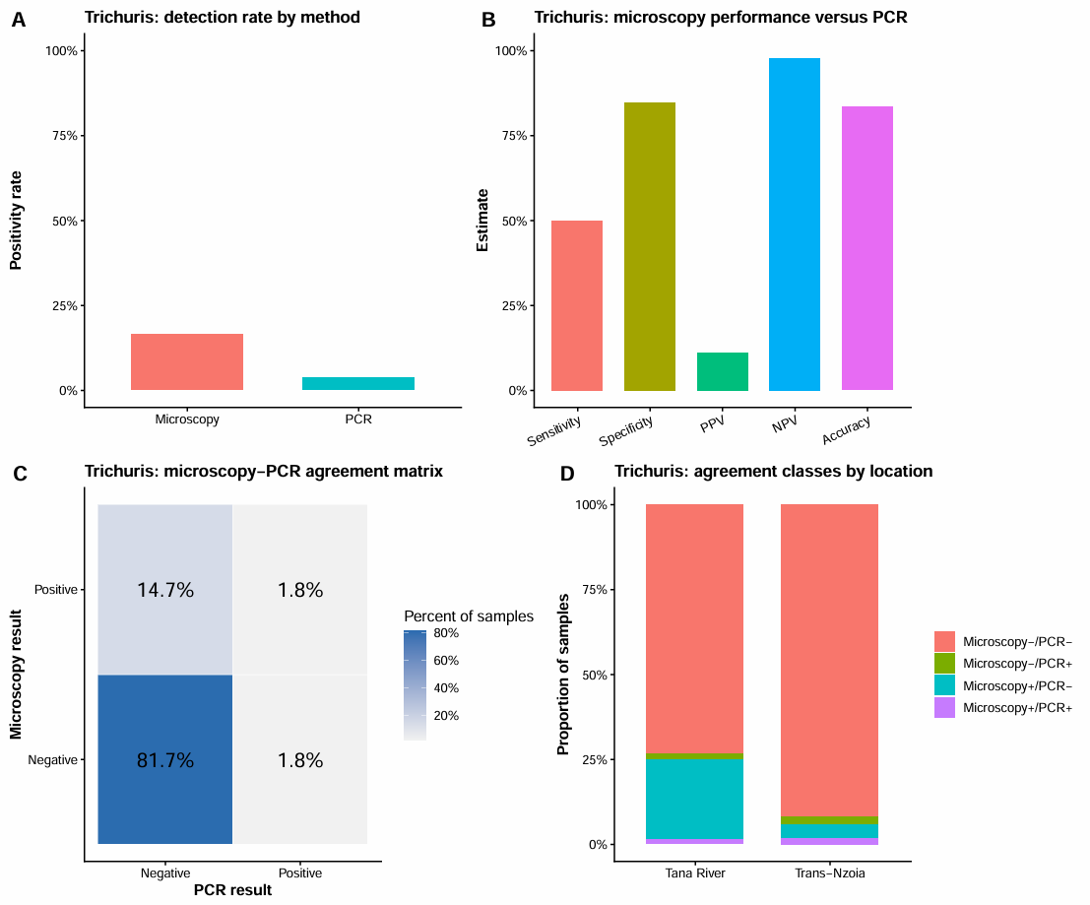
Figure 4.8: Diagnostic performance of microscopy relative to PCR for overall Trichuris detection. (A) Overall proportion of samples classified as positive by microscopy and PCR. (B) Diagnostic performance estimates for microscopy using PCR as the reference method, including sensitivity, specificity, positive predictive value (PPV), negative predictive value (NPV) and accuracy. (C) Agreement matrix showing the number of samples classified as microscopy-negative and PCR-negative, microscopy-negative and PCR-positive, microscopy-positive and PCR-negative, and microscopy-positive and PCR-positive. (D) Distribution of microscopy-PCR agreement classes across study locations. Together, the panels show that microscopy detected more samples as positive than PCR, but exhibited limited agreement with PCR and substantial discordance, particularly through microscopy-positive and PCR-negative classifications.
Table 4.4: Microscopy–PCR 2 × 2 classification matrix for Trichuris parasite detection
Microscopy result | PCR result | n
Negative | Negative | 89
Negative | Positive | 2
Positive | Negative | 16
Positive | Positive | 2
The agreement matrix indicated that 2 samples were positive by both microscopy and PCR for Trichuris (Table 4.4), whereas 89 were negative by both methods. In contrast, substantial discordance was observed, with 16 samples classified as microscopy-positive but PCR-negative and 2 classified as microscopy-negative but PCR-positive Diagnostic figure.

CHAPTER FIVE

DISCUSSION

5.1 Discussion
The present study investigated the prevalence of potentially zoonotic gastrointestinal parasites among the understudied groups of non-human primates in selected sites across Tana River, Trans-Nzoia and Samburu counties. The study species included Mangabey, Red colobus, De Brazza’s monkeys, Syke monkeys from Tana River, the Black and White colobus from Kitale museum and Samburu Mathews ranges. Overall parasite prevalence and richness varied across both host species and study sites.
The parasite prevalence patterns across the three study locations demonstrated clear spatial variation in parasite composition and infection intensity, reflecting differences in ecological conditions, host–environment interactions, and potential transmission pathways. Protozoan parasites were more prevalent than helminths across all sites, with Entamoeba spp. and Balantidium spp. showing consistently high prevalence, particularly in Trans-Nzoia and Tana River Counties. The high occurrence of these protozoa suggests widespread environmental contamination of water sources, as both parasites are transmitted through fecal oral routes and persist as environmentally resistant cysts. Higher protozoan richness was observed in Tana River and Trans Nzoia, where most samples contained one to two protozoan taxa, while samples from Samburu generally showed lower richness levels. This pattern may be explained by environmental differences, as Trans Nzoia and Tana River Counties are generally humid and temperate compared to the hot and dry conditions typical of Samburu County. These observations align with previous studies indicating that protozoan infections are more common in humid environments, especially in areas with poor sanitation (Haque, 2007).
Nematode richness showed the greatest variation in Tana River, where several samples contained multiple co-occurring nematode taxa. Trans Nzoia consistently exhibited low nematode richness, while Samburu displayed an intermediate pattern. Tana River exhibited the highest overall parasite prevalence and richness, including elevated levels of Trichuris spp., Strongyloides spp., Oesophagostomum spp., and the only occurrence of Ascaris spp. Similar to previous study by (D. N. M. Mbora & Munene, 2006) this pattern is likely influenced by the riverine ecosystem, which facilitates waterborne transmission and supports prolonged survival of infective parasite stages. In contrast, Samburu showed moderate prevalence across most parasite taxa, with notable occurrences of Streptopharagus spp., soil nematodes and Abbreviata spp., possibly reflecting the combined effects of semi-arid conditions and localized environmental contamination as highlighted from previous studies which have revealed persistence of parasite survival in semi-arid conditions (Waruru et al., 2005). In agreement with previous study by (Masaku et al., 2020), Trans Nzoia County displayed comparatively lower prevalence for many helminths, although protozoan infections remained common, suggesting that climatic and land-use factors may limit helminth survival while protozoa continue to circulate efficiently. The uneven distribution of soil-transmitted helminths, including Ascaris spp. and soil nematodes, further highlights the role of local environmental conditions such as soil type, moisture, and human–wildlife overlaps in shaping transmission dynamics (Gillespie, Chapman, & Greiner, 2005). Collectively, these findings emphasize that environmental and ecological factors are critical determinants of parasite prevalence, underscoring the need for site-specific surveillance and intervention strategies (Mapagha-Boundoukou et al., 2025).
When stratified by host species, protozoan richness among Mangabey monkeys, De Brazza’s monkeys, and black-and-white colobus monkeys showed comparatively higher values, whereas red colobus monkeys tended to exhibit lower protozoan richness. Although some overlap occurred among host groups, the distributions indicate clear host-specific differences in parasite richness, supporting heterogeneity in exposure and susceptibility across primate taxa (Vonfeld et al., 2022). Similarly, nematode richness appeared highest and most variable among Sykes monkeys and Mangabey monkeys, with Mangabey monkeys exhibiting the widest range and highest upper-end values, consistent with a greater burden of helminth co-occurrence in these hosts (Ilík et al., 2023). The Tana River Mangabey exhibited the highest parasite burden, particularly with respect to Strongyloides spp., Enterobius vermicularis, Oesophagostomum spp., and Ascaris spp. infections. This may be attributed to their socioecology and feeding behavior. Mangabeys, which are critically endangered in the lower Tana River region, utilize fragmented forest patches characterized by high anthropogenic activity and spend considerable time foraging on the ground and raiding crops in farms, thereby increasing interactions with humans and exposure to parasites (Kivai, 2018). Previous studies have similarly reported that Mangabey monkeys face an elevated risk of gastrointestinal parasite infection due to ecological exposure resulting from habitat degradation (Kivasu, 2021). Environmental degradation has altered parasite transmission dynamics by increasing the likelihood of contact with fecally contaminated environments, thereby facilitating fecal–oral transmission (Mbora & Munene, 2006).
Sykes monkeys, sampled exclusively from Tana River County, exhibited a subsequently high parasite prevalence and showed a notable tendency toward multiple co-infections, including Trichuris spp., Strongyloides spp., Streptopharagus spp., and Entamoeba spp. This pattern is consistent with findings by Obanda et al. (2019), which demonstrated that habitat fragmentation and increasing human encroachment elevate co-infection risk in primate populations. The mixed arboreal-terrestrial behavior of Sykes monkeys may expose them to a wider range of transmission pathways, facilitating the accumulation of multiple parasite species even when overall prevalence remains moderate. These findings are in agreement with studies which have shown that Syke monkeys have a high infestation of gastrointestinal parasites (Munene et al., 1998b). Such co-infections may have important implications for host health, parasite persistence and cross-species transmission dynamics.
Red colobus and black-and-white colobus generally exhibited lower nematode richness, with most samples clustering around zero or one taxon. This could be attributed to the fact that the colobines are arboreal and spend most of their time in the canopies reducing their contact with soil hence lowering the chances of acquiring the nematode infections which are soil transmitted (Sirima et al., 2021). The Red Colobus, which is a critically endangered species in Tana River has specialized leaf-based diet which contains secondary metabolites and chemical properties hence reducing parasite establishment in the gut which could account for their general low parasitic prevalence. The Colobines compared to other primates move in smaller group size with limited ranging limiting re-exposure with groups and reducing the transmission cycles (Minhós et al., 2023).
De Brazza’s monkeys, in contrast, exhibited a parasite profile dominated by protozoan infections, including Entamoeba spp., Balantidium spp., and Eimeria spp., alongside helminths such as Abbreviata spp. and other soil nematodes. Their semi-aquatic lifestyle and strong reliance on riverine habitats likely play a critical role in shaping this infection pattern, as frequent use of water sources increases exposure to waterborne cysts and oocysts (Medkour et al., 2020). This observation supports previous studies demonstrating that water-mediated transmission is a major driver of protozoan infections in primates inhabiting riverine forests (Nichols & Gómez, 2014). The high prevalence of Abbreviata spp. further suggests a dietary component to infection risk, as this parasite is transmitted via arthropod intermediate hosts. Although the zoonotic potential of Abbreviata spp is less well characterized, the presence of environmentally persistent helminth of public health relevance highlights the role of De Brazza’s monkeys in maintaining and disseminating waterborne parasites in ecosystems frequently used by humans. Although the numerical prevalence varied among the NHP species, these findings indicate similar exposure risks among the studied NHPs. However, the slight variation observed may have reflected other cofounding factors that may have determined the infection rates, including variation in sample size, host behavior, feeding habits, and environmental conditions (Mbuthia et al. 2020).
Collectively, these findings emphasize that parasite prevalence and composition among NHPs are strongly shaped by species-specific ecology, behavior and habitat use, with clear implications for zoonotic risk. Terrestrial and semi-terrestrial species, particularly mangabeys, appear to play a disproportionate role in maintaining soil-transmitted helminths of zoonotic concern, while riverine-associated species such as De Brazza’s monkeys contribute significantly to the circulation of waterborne protozoa. In increasingly fragmented landscapes where humans, wildlife, and livestock interact closely, these species-specific infection patterns underscore the need for integrated One Health surveillance approaches that incorporate wildlife hosts into public health and conservation planning.
Molecular screening and phylogenetic analysis revealed the presence of two Entamoeba species; E. hartmani and unidentified spp with the latter clustering closely with an Entamoeba strain that has previously been observed in Yaks (Ren et al., 2021). Entamoeba hartmanni is a non-pathogenic species that has been reported in humans, non-human primates, cattle and other ruminants (Kanyari et al. 2017). Yaks although not found in Kenya, are classified as livestock and are related to other ruminants which may explain the genetic proximity of the parasites observed in the current study (Li et al., 2018).While some Entamoeba sequences from the NHPs showed genetic similarity to strains in previously reported hosts, these relationships likely represent shared evolutionary ancestry and shared ecological factors rather than evidence of active cross species transmission. Similarly, the close phylogenetic association of E. hartmani from humans and baboons (Papio anubis)(Medkour et al., 2020) suggests genetic relatedness and cannot be interpreted as spillover or co-infection without sampling both hosts. Consistent with (McCord et al., 2014), primate specific clusters was observed in the Colobine species suggesting a host restricted evolutionary pattern rather than a recent interspecies transmission. These phylogenetic patterns provide insights into evolutionary relationships of Entamoeba spp. detected in these groups of NHPs and future studies need to utilize a one health sampling approach to investigate the presence of shared parasite species and possible transmission pathways between humans, NHPs and livestock.
Sensitivity and specificity of diagnostic tests varied in different parasite species. Although microscopy identified a greater number of nematode-positive samples than PCR, this finding does not necessarily indicate superior diagnostic sensitivity. The discrepancy may reflect limitations of PCR, including incomplete amplification by universal primers, inefficient DNA extraction from thick-shelled nematode eggs, the presence of PCR inhibitors which has been frequently reported in fecal samples and low concentrations of parasite DNA (Mbuthia et al., 2021b). Additionally, microscopy detects morphologically identifiable eggs regardless of DNA integrity, whereas PCR requires successful DNA extraction and amplification (Demeler et al., 2013).
For Entamoeba screening, similar agreement patterns were observed in Tana River and Trans Nzoia, with concordant positive results predominating at both sites. Although discordant categories were present in both locations, the overall pattern suggested that microscopy captured most Entamoeba-positive samples identified by PCR, but with some loss of specificity. Overall, these findings indicated that microscopy performed reasonably well for Entamoeba detection relative to PCR, particularly as a screening tool for identifying positive cases, although molecular confirmation remained important for improving specificity and for resolving microscopy-negative but PCR-positive cases (Abbas et al., 2023). In the current study, PCR detected slightly more Entamoeba infections compared to microscopy, which was contrary to the helminth’s detection. This highlighted that PCR is more sensitive in the identification of Entamoeba spp. The discordant results between microscopy and PCR detection of Entamoeba suggest differences in the detection capabilities and limitations of the two methods rather than unequivocal false-positive or false-negative results. Higher proportion observed in the PCR-positive/microscopy-negative samples indicates that PCR may detect infections missed by microscopy, whereas microscopy-positive and PCR-negative samples may reflect limitations in molecular detection, including inefficient lysis or low DNA recovery, particularly for resistant stages. This is in agreement with other research findings from earlier studies, where PCR detected more Entamoeba cases outperforming microscopy (Jirků-Pomajbíková et al., 2016b; (Kalousová et al., 2014; Sleeman et al., 2000; Gillespie et al., 2010). In low-middle-income countries such as Kenya, Entamoeba remains a public health challenge due to the fact that advanced diagnostic methods are cost effective, and as a result of this, microscopy remains a commonly used method for screening and identification of Entamoeba spp (Ogalo et al., 2025). Its efficiency is, however, limited by low resolution and difficulty in detecting closely related Entamoeba spp (Van den Bossche et al., 2015). Molecular techniques have enabled the distinction of Entamoeba species even within the ribosomal lineages, where traditional microscopic methods have not succeeded. (Servián et al., 2024). Accurate screening and identification of Entamoeba species is thus cardinal in designing control strategies that target non-human hosts such as wild-ranging NHPs (Heng & Chua, 2024). This study underscores the higher sensitivity of PCR for protozoan parasites, particularly Entamoeba spp., and highlights its ability to differentiate species that are indistinguishable under a microscope.
Microscopy had limited detection value for confirming Trichuris infection relative to PCR. Although it performed well in identifying negatives, its low positive predictive value indicates that microscopy-positive Trichuris results should be interpreted cautiously and ideally confirmed using molecular methods. The microscopic comparison specific to Trichuris further highlights the limitations of conventional diagnostic approaches. Most samples from Trans Nzoia and Tana River were negative by microscopy, with only a small proportion testing positive. PCR detection of Trichuris yielded even fewer positive results, suggesting that infections were present at low intensity or that genetic material was insufficient for amplification in many samples (Stensvold & Nielsen, 2012). The observed discrepancy between microscopy and PCR findings underscores challenges such as intermittent egg shedding, sample preservation issues, and methodological constraints that affect sensitivity and specificity.
Overall, microscopy identified a higher proportion of samples as nematode positive than PCR, detecting approximately 34% of samples compared with 23% by PCR screening. This could be attributed to the fact that the nematode eggs were used for molecular assays which may have made it difficult to lyse the egg shells as it has previously been reported by (Demeler et al., 2013). The moderate specificity and low positive predictive value was an indication that for nematode detection, microscopy was reasonably good although not excellent since many positive results are treated as false-positive despite it being a suitable tool for epidemiological surveillance (Parija & Poddar, 2025). Overall diagnostic accuracy was in agreement between the two methods when compared with the reference method with over half of the test results correctly classified. However, despite this higher positivity rate, microscopy showed limited diagnostic performance relative to PCR (Fleitas et al., 2025.). From previous studies it has been reported that intermittent shedding of helminth eggs can result in false negatives, affecting microscopy-based diagnosis (Mbuthia et al., 2021). This highlights the importance of combining microscopic and molecular approaches for improved detection.
The agreement matrix portrays an evidence of limited concordance between the two methods an indication of nematode detection of different subsets of infections and that microscopy alone may not be reliable especially in studies requiring accurate detection and characterization (Valkiūnas et al., 2008). When agreement patterns were examined by location, spatial variation was evident. Tana River showed a comparatively larger proportion of microscopy-positive and PCR-negative classifications, whereas Trans-Nzoia showed a larger contribution of microscopy-negative and PCR-negative agreement together with a noticeable proportion of microscopy-negative and PCR-positive samples (Miswan et al., 2022b). These findings suggest that method concordance may vary across sites, potentially reflecting differences in parasite burden and life cycle stage, sample quality, preservation conditions or the inherent limitations of microscopy and PCR for detecting overall parasitic infection (Stensvold & Nielsen, 2012). These findings highlight the importance of considering site-specific ecological and methodological factors when evaluating the performance of diagnostic assays in field studies."

CHAPTER SIX
CONCLUSION AND RECOMMENDATIONS
6.1 Conclusion
- The study established that NHPs play a critical ecological role and anthropogenic factors in shaping parasitic prevalence, nematode infections were present across all the locations with prevalence relatively low and unevenly distributed whereas protozoa particularly Entamoeba was highly prevalent indicating a significant public health concern.
- Incorporation of conventional and molecular techniques was paramount in the essence that morphologically similar parasites were identified to the specie level through molecular sequencing and characterization.
- The study demonstrated that despite microscopy being used in routine detection of parasites, molecular screening was more sensitive in detecting protozoan infections compared to microscopy whereas microscopy outperformed PCR in nematode detection despite an indication of a significant number of false positives.

6.2 Recommendations
- The study recommends strengthening surveillance measures and embracing the One health approach that integrates the wildlife, human and livestock so as to enhance potentially zoonotic parasite monitoring and spillage in the human-wildlife interface.
- Future studies should explore next-generation sequencing to enhance parasite diversity, transmission patterns and potential zoonotic risks associated with gastrointestinal parasites in these regions.
- Capacity building in molecular diagnostics and quality assurance for microscopy should be strengthened to improve diagnostic accuracy. Additionally, further validation studies using larger sample sizes and reference standards are recommended to better quantify diagnostic performance and support reliable parasite surveillance in these regions.

REFERENCES
Abbas, A. H., ELShahat, E. S. A., & Abdelglil, H. M. (2023). Molecular detection of Entamoeba histolytica in diarrheic fecal samples from patients attending National Hepatology and Tropical Medicine Research Institute. Journal of Medicine in Scientific Research, 6(1). https://doi.org/10.59299/2537-0928.1033
Akinyi, M. Y., Jansen, D., Habig, B., Gesquiere, L. R., Alberts, S. C., & Archie, E. A. (2019). Costs and drivers of helminth parasite infection in wild female baboons. Journal of Animal Ecology, 88(7), 1029–1043. https://doi.org/10.1111/1365-2656.12994
Ali, I. K. M., Clark, C. G., & Petri, W. A. (2008). Molecular Epidemiology of Amebiasis. Infection, Genetics and Evolution : Journal of Molecular Epidemiology and Evolutionary Genetics in Infectious Diseases, 8(5), 698–707. https://doi.org/10.1016/j.meegid.2008.05.004
Altmann, J. (1974). Observational Study of Behavior: Sampling Methods. https://doi.org/10.1163/156853974X00534
Anderson, C. F., Oukka, M., Kuchroo, V. J., & Sacks, D. (2007). CD4(+)CD25(-)Foxp3(-) Th1 cells are the source of IL-10-mediated immune suppression in chronic cutaneous leishmaniasis. The Journal of Experimental Medicine, 204(2), 285–297. https://doi.org/10.1084/jem.20061886
Appleton, C. C., Krecek, R. C., Verster, A., Bruorton, M. R., & Lawes, M. J. (1994). Gastro-intestinal parasites of the Samango monkey, Cercopithecus mitis, in Natal, South Africa. Journal of Medical Primatology, 23(1), 52–55. https://doi.org/10.1111/j.1600-0684.1994.tb00096.x
Austin, K. F. (2021). Degradation and disease: Ecologically unequal exchanges cultivate emerging pandemics. World Development, 137, 105163. https://doi.org/10.1016/j.worlddev.2020.105163
Barbecho, J. M., Bowman, D. D., & Liotta, J. L. (2018). Comparative performance of reference laboratory tests and in-clinic tests for Giardia in canine feces. Parasites & Vectors, 11(1), 444. https://doi.org/10.1186/s13071-018-2990-6
Barratt, J. L. N., Harkness, J., Marriott, D., Ellis, J. T., & Stark, D. (2011). A review of Dientamoeba fragilis carriage in humans: Several reasons why this organism should be considered in the diagnosis of gastrointestinal illness. Gut Microbes, 2(1), 3–12. https://doi.org/10.4161/gmic.2.1.14755
Begum, S., Quach, J., & Chadee, K. (2015). Immune Evasion Mechanisms of Entamoeba histolytica: Progression to Disease. Frontiers in Microbiology, 6, 1394. https://doi.org/10.3389/fmicb.2015.01394
Belay, E. D., Kile, J. C., Hall, A. J., Barton-Behravesh, C., Parsons, M. B., Salyer, S., & Walke, H. (2017). Zoonotic Disease Programs for Enhancing Global Health Security. Emerging Infectious Diseases, 23(Suppl 1), S65–S70. https://doi.org/10.3201/eid2313.170544
Berrilli, F., Prisco, C., Friedrich, K. G., Di Cerbo, P., Di Cave, D., & De Liberato, C. (2011). Giardia duodenalis assemblages and Entamoeba species infecting non-human primates in an Italian zoological garden: Zoonotic potential and management traits. Parasites & Vectors, 4, 199. https://doi.org/10.1186/1756-3305-4-199
Berzosa, P., de Lucio, A., Romay-Barja, M., Herrador, Z., González, V., García, L., Fernández-Martínez, A., Santana-Morales, M., Ncogo, P., Valladares, B., Riloha, M., & Benito, A. (2018a). Comparison of three diagnostic methods (microscopy, RDT, and PCR) for the detection of malaria parasites in representative samples from Equatorial Guinea. Malaria Journal, 17, 333. https://doi.org/10.1186/s12936-018-2481-4
Berzosa, P., de Lucio, A., Romay-Barja, M., Herrador, Z., González, V., García, L., Fernández-Martínez, A., Santana-Morales, M., Ncogo, P., Valladares, B., Riloha, M., & Benito, A. (2018b). Comparison of three diagnostic methods (microscopy, RDT, and PCR) for the detection of malaria parasites in representative samples from Equatorial Guinea. Malaria Journal, 17(1), 333. https://doi.org/10.1186/s12936-018-2481-4
Bethge, J., Razafimampiandra, J. C., Wulff, A., & Dausmann, K. H. (2023). Seasonal changes in the parasite prevalence of a small Malagasy lemur species (Lepilemur edwardsi). Integrative Zoology, 18(3), 427–439. https://doi.org/10.1111/1749-4877.12647
Blagg, W., Schloegel, E. L., Mansour, N. S., & Khalaf, G. I. (1955). A new concentration technic for the demonstration of protozoa and helminth eggs in feces. The American Journal of Tropical Medicine and Hygiene, 4(1), 23–28. https://doi.org/10.4269/ajtmh.1955.4.23
Bloomfield, L. S. P., McIntosh, T. L., & Lambin, E. F. (2020). Habitat fragmentation, livelihood behaviors, and contact between people and nonhuman primates in Africa. Landscape Ecology, 35(4), 985–1000. https://doi.org/10.1007/s10980-020-00995-w
Borad, A., & Ward, H. (2010). Human immune responses in cryptosporidiosis. Future Microbiology, 5, 507–519. https://doi.org/10.2217/fmb.09.128
Butynski, T., & Mwangi, G. (2023). Conservation Status and Distribution of the Tana River Red Colobus and Crested Mangabey.
Changes in forest fragment sizes and primate population trends along the River Tana floodplain, Kenya. (2005). African Journal of Ecology, 43(2), 81–90. https://doi.org/10.1111/J.1365-2028.2005.00535.X
Chirchir, E., Sudoi, V., & Kimanzi, J. (2018). Impacts of Forest Disturbance on Food Trees of Colobus angolensis in Kibonge Forest, Kenya. Africa Environmental Review Journal, 3(1), 82–93. https://doi.org/10.2200/aerj.v3i1.66
Clark, F. E. (2011). Space to choose: Network analysis of social preferences in a captive chimpanzee community, and implications for management. American Journal of Primatology, 73(8), 748–757. https://doi.org/10.1002/ajp.20903
Collender, P. A., Kirby, A. E., Addiss, D. G., Freeman, M. C., & Remais, J. V. (2015). Methods for Quantification of Soil-Transmitted Helminths in Environmental Media: Current Techniques and Recent Advances. Trends in Parasitology, 31(12), 625–639. https://doi.org/10.1016/j.pt.2015.08.007
Cunningham, A. A., Daszak, P., & Wood, J. L. N. (2017). One Health, emerging infectious diseases and wildlife: Two decades of progress? Philosophical Transactions of the Royal Society B: Biological Sciences, 372(1725), 20160167. https://doi.org/10.1098/rstb.2016.0167
Dann, S. M., Manthey, C. F., Le, C., Miyamoto, Y., Gima, L., Abrahim, A., Cao, A. T., Hanson, E. M., Kolls, J. K., Raz, E., Cong, Y., & Eckmann, L. (2015). IL-17A promotes protective IgA responses and expression of other potential effectors against the lumen-dwelling enteric parasite Giardia. Experimental Parasitology, 156, 68–78. https://doi.org/10.1016/j.exppara.2015.06.003
Demeler, J., Ramünke, S., Wolken, S., Ianiello, D., Rinaldi, L., Gahutu, J. B., Cringoli, G., Samson-Himmelstjerna, G. von, & Krücken, J. (2013). Discrimination of Gastrointestinal Nematode Eggs from Crude Fecal Egg Preparations by Inhibitor-Resistant Conventional and Real-Time PCR. PLOS ONE, 8(4), e61285. https://doi.org/10.1371/journal.pone.0061285
Devaux, C. A., Mediannikov, O., Medkour, H., & Raoult, D. (2019). Infectious Disease Risk Across the Growing Human-Non Human Primate Interface: A Review of the Evidence. Frontiers in Public Health, 7, 305. https://doi.org/10.3389/fpubh.2019.00305
Dreesen, L., De Bosscher, K., Grit, G., Staels, B., Lubberts, E., Bauge, E., & Geldhof, P. (2014). Giardia muris infection in mice is associated with a protective interleukin 17A response and induction of peroxisome proliferator-activated receptor alpha. Infection and Immunity, 82(8), 3333–3340. https://doi.org/10.1128/IAI.01536-14
Dupont, C. D., Christian, D. A., & Hunter, C. A. (2012). Immune response and immunopathology during toxoplasmosis. Seminars in Immunopathology, 34(6), 793–813. https://doi.org/10.1007/s00281-012-0339-3
Edward, M., Heniedy, A. M., Saminu, A., Florence Mary, J. J., Ahmed, D. A., Engmann, S. T., Onyeaghala, C., & Shah, S. (n.d.). Climate change and contagion: The emerging threat of zoonotic diseases in Africa. Infection Ecology & Epidemiology, 15(1), 2441534. https://doi.org/10.1080/20008686.2024.2441534
Ej, B. (1985). De Brazza’s monkeys (Cercopithecus neglectus) in Kenya: Census, distribution, and conservation. American Journal of Primatology, 8(4). https://doi.org/10.1002/ajp.1350080402
Fallon, P. G., Ballantyne, S. J., Mangan, N. E., Barlow, J. L., Dasvarma, A., Hewett, D. R., McIlgorm, A., Jolin, H. E., & McKenzie, A. N. J. (2006). Identification of an interleukin (IL)-25-dependent cell population that provides IL-4, IL-5, and IL-13 at the onset of helminth expulsion. The Journal of Experimental Medicine, 203(4), 1105–1116. https://doi.org/10.1084/jem.20051615
Fallon, P. G., & Mangan, N. E. (2007). Suppression of TH2-type allergic reactions by helminth infection. Nature Reviews. Immunology, 7(3), 220–230. https://doi.org/10.1038/nri2039
Fashing, P. (2001). Feeding Ecology of Guerezas in the Kakamega Forest, Kenya: The Importance of Moraceae Fruit in Their Diet. International Journal of Primatology, 22, 579–609. https://doi.org/10.1023/A:1010737601922
Fashing, P. J. (2001). Activity and Ranging Patterns of Guerezas in the Kakamega Forest: Intergroup Variation and Implications for Intragroup Feeding Competition. International Journal of Primatology, 22(4), 549–577. https://doi.org/10.1023/A:1010785517852
Fayer, R., & Xiao, L. (2007). Cryptosporidium and Cryptosporidiosis. CRC Press.
Figueiredo, C. A., Düsedau, H. P., Steffen, J., Gupta, N., Dunay, M. P., Toth, G. K., Reglodi, D., Heimesaat, M. M., & Dunay, I. R. (2019). Immunomodulatory Effects of the Neuropeptide Pituitary Adenylate Cyclase-Activating Polypeptide in Acute Toxoplasmosis. Frontiers in Cellular and Infection Microbiology, 9, 154. https://doi.org/10.3389/fcimb.2019.00154
Fleitas, P. E., Bengtson, M., Messa, A., Bartilol, B., Gelaye, W., Kepha, S., Gandasegui, J., de Jesus, Á., Novela, V., Mandomando, I., Mwandawiro, C., Enbiale, W., Krolewiecki, A., Muñoz, J., Rono, M., & van Lieshout, L. (n.d.). Assessing the diagnostic value of qPCR for Trichuris trichiura: Sub-analysis of a multi-country clinical trial to determine the efficacy of albendazole compared to an albendazole-ivermectin fixed dose combination. Frontiers in Parasitology, 4, 1679294. https://doi.org/10.3389/fpara.2025.1679294
Fredrick, M., Danson, M., John, K., Stanislaus, K., David, N., Maina, N., Michael, G., Suleiman, M., & Mercy, A. (2021). Schistosoma mansoni and soil transmtted helminths in olive baboons and potential zoonosis. Veterinary Medicine and Science, 7(5), 2026–2031. https://doi.org/10.1002/vms3.495
Gautier-Hion, A., & Gautier, J.-P. (1978). The De Brazza’s monkey: An original strategy. Zeitschrift Für Tierpsychologie, 46(1), 84–104. https://doi.org/10.1111/j.1439-0310.1978.tb01440.x
Gery, W., Mbida, M., Abdoulmoumini, M., & Silas Lendzele, S. (2020). Ecologia Research Article Gastrointestinal Helminths of Captive Non-human Primates in Cameroon. In Ecologia (Vol. 10). https://doi.org/10.3923/ecologia.2020.30.37
Ghai, R. R., Chapman, C. A., Omeja, P. A., Davies, T. J., & Goldberg, T. L. (2014). Nodule worm infection in humans and wild primates in Uganda: Cryptic species in a newly identified region of human transmission. PLoS Neglected Tropical Diseases, 8(1), e2641. https://doi.org/10.1371/journal.pntd.0002641
Gillespie, P. S. (n.d.). Template:Gillespie, 2006—Wikispecies. Retrieved December 16, 2021, from https://species.wikimedia.org/wiki/Template:Gillespie,_2006
Gillespie, T. R., Chapman, C. A., & Greiner, E. C. (2005). Effects of logging on gastrointestinal parasite infections and infection risk in African primates. Journal of Applied Ecology, 42(4), 699–707. https://doi.org/10.1111/j.1365-2664.2005.01049.x
Gillespie, T. R., Nunn, C. L., & Leendertz, F. H. (2008). Integrative approaches to the study of primate infectious disease: Implications for biodiversity conservation and global health. American Journal of Physical Anthropology, 137(S47), 53–69. https://doi.org/10.1002/ajpa.20949
Gomes, J. F., Hoshino-Shimizu, S., Dias, L. C. S., Araujo, A., Castilho, V. L. P., & Neves, F. (2004). Evaluation of a novel kit (TF-test) for the diagnosis of intestinal parasitic infections. Journal of Clinical Laboratory Analysis, 132. https://doi.org/10.1002/jcla.20011
González-Barrio, D. (2022). Zoonoses and Wildlife: One Health Approach. Animals, 12(4), Article 4. https://doi.org/10.3390/ani12040480
Hahn, N. E., Proulx, D., Muruthi, P. M., Alberts, S., & Altmann, J. (2003). Gastrointestinal Parasites in Free-Ranging Kenyan Baboons (Papio cynocephalus and P. anubis). International Journal of Primatology, 24(2), 271–279. https://doi.org/10.1023/A:1023092915171
Harper, K. N., Zuckerman, M. K., Turner, B. L., & Armelagos, G. J. (2013). Primates, Pathogens, and Evolution: A Context for Understanding Emerging Disease. Primates, Pathogens, and Evolution, 389–409. https://doi.org/10.1007/978-1-4614-7181-3_13
Heng, Y., & Chua, D. H. H. (2024). Risk-Based Gastrointestinal Parasite Control in a Tropical Zoological Institute. Journal of Zoological and Botanical Gardens, 5(2), Article 2. https://doi.org/10.3390/jzbg5020014
Holmstrom, S. E., Fitch, P. F., & Eisner, E. R. (2004). Veterinary Dental Techniques for the Small Animal Practitioner—E-Book. Elsevier Health Sciences.
Hooshyar, H., Rostamkhani, P., Arbabi, M., & Delavari, M. (2019). Giardia lamblia infection: Review of current diagnostic strategies. Gastroenterology and Hepatology from Bed to Bench, 12(1), 3–12.
Huffman, M. A., Gotoh, S., Turner, L. A., Hamai, M., & Yoshida, K. (1997). Seasonal trends in intestinal nematode infection and medicinal plant use among chimpanzees in the Mahale Mountains, Tanzania. Primates, 38(2), 111–125. https://doi.org/10.1007/BF02382002
Ilík, V., Kreisinger, J., Modrý, D., Schwarz, E. M., Tagg, N., Mbohli, D., Nkombou, I. C., Petrželková, K. J., & Pafčo, B. (2023). High diversity and sharing of strongylid nematodes in humans and great apes co-habiting an unprotected area in Cameroon. PLOS Neglected Tropical Diseases, 17(8), e0011499. https://doi.org/10.1371/journal.pntd.0011499
Impacts of Forest Disturbance on Food Trees of Colobus angolensis in Kibonge Forest, Kenya. (2018, December 6). SciSpace - Paper. https://scispace.com/papers/impacts-of-forest-disturbance-on-food-trees-of-colobus-4ck30xcv1i
Jirků-Pomajbíková, K., Čepička, I., Kalousová, B., Jirků, M., Stewart, F., Levecke, B., Modrý, D., Piel, A. K., & Petrželková, K. J. (2016). Molecular identification of Entamoeba species in savanna woodland chimpanzees (Pan troglodytes schweinfurthii). Parasitology, 143(6), 741–748. https://doi.org/10.1017/S0031182016000263
Jones, K. E., Patel, N. G., Levy, M. A., Storeygard, A., Balk, D., Gittleman, J. L., & Daszak, P. (2008). Global trends in emerging infectious diseases. Nature, 451(7181), 990–993. https://doi.org/10.1038/nature06536
Kalousová, B., Hasegawa, H., Petrželková, K. J., Sakamaki, T., Kooriyma, T., & Modrý, D. (2016). Adult hookworms (Necator spp.) collected from researchers working with wild western lowland gorillas. Parasites & Vectors, 9, 75. https://doi.org/10.1186/s13071-016-1357-0
Kanyari1, P. W. N., Kagira, J. M., & Mhoma, J. R. L. (2017). Prevalence of endoparasites in cattle within urban and peri-urban areas of Lake Victoria Basin, Kenya with special reference to zoonotic potential. http://localhost/xmlui/handle/123456789/2641
King, L. E., Douglas-Hamilton, I., & Vollrath, F. (2007). African elephants run from the sound of disturbed bees. Current Biology: CB, 17(19), R832-833. https://doi.org/10.1016/j.cub.2007.07.038
Köndgen, S., Kühl, H., N’Goran, P. K., Walsh, P. D., Schenk, S., Ernst, N., Biek, R., Formenty, P., Mätz-Rensing, K., Schweiger, B., Junglen, S., Ellerbrok, H., Nitsche, A., Briese, T., Lipkin, W. I., Pauli, G., Boesch, C., & Leendertz, F. H. (2008). Pandemic human viruses cause decline of endangered great apes. Current Biology: CB, 18(4), 260–264. https://doi.org/10.1016/j.cub.2008.01.012
Koua, E. L., Njingang, J. R. N., Kimenyi, J. P., Williams, G. S., Okeibunor, J., Oka, S., & Gueye, A. S. (2023). Trends in public health emergencies in the WHO African Region: An analysis of the past two decades public health events from 2001 to 2022. BMJ Global Health, 8(10), e012015. https://doi.org/10.1136/bmjgh-2023-012015
Kouassi, R. Y. W., McGraw, S. W., Yao, P. K., Abou-Bacar, A., Brunet, J., Pesson, B., Bonfoh, B., N’goran, E. K., & Candolfi, E. (2015). Diversity and prevalence of gastrointestinal parasites in seven non-human primates of the Taï National Park, Côte d’Ivoire. Parasite, 22, 1. https://doi.org/10.1051/parasite/2015001
Kurpiers, L. A., Schulte-Herbrüggen, B., Ejotre, I., & Reeder, D. M. (2015). Bushmeat and Emerging Infectious Diseases: Lessons from Africa. Problematic Wildlife, 507–551. https://doi.org/10.1007/978-3-319-22246-2_24
Lafferty, K. D., & Gerber, L. (2002). Good medicine for conservation biology: The intersection of epidemiology and conservation theory. Conservation Biology, 16(3), 593–604. https://doi.org/10.1046/j.1523-1739.2002.00446.x
Lagat, J., Kivai, S., Mwaura, D., Nyachieo, A., Lekolool, I., Wango, T., Ng’ang’a, S., Ochola, L., Nyanjom, S., Kamau, L., Ochola, L., & Akinyi, M. (2026). Epidemiology and Molecular Characterisation of Entamoeba Species in Selected Non-Human Primate Populations in Tana River and Trans Nzoia Counties, Kenya. East African Journal of Health and Science, 9, 43–58. https://doi.org/10.37284/eajhs.9.2.4854
Laurent, F., & Lacroix-Lamandé, S. (2017). Innate immune responses play a key role in controlling infection of the intestinal epithelium by Cryptosporidium. International Journal for Parasitology, 47(12), 711–721. https://doi.org/10.1016/j.ijpara.2017.08.001
Lebbad, M. (2010). Molecular Diagnosis and Characterization of Two Intestinal Protozoa: Entamoeba histolytica & Giardia intestinalis. Institutionen för mikrobiologi, tumör- och cellbiologi / Department of Microbiology, Tumor and Cell Biology. http://openarchive.ki.se/xmlui/handle/10616/39994
Li, J., Wang, Z., Karim, M. R., & Zhang, L. (2020). Detection of human intestinal protozoan parasites in vegetables and fruits: A review. Parasites & Vectors, 13(1), 380. https://doi.org/10.1186/s13071-020-04255-3
Li, X. H., Li, K., Zhang, H., Gan, P., Luo, H. Q., Han, Z. Q., Mehmood, K., & Shahzad, M. (2018). Epidemiological investigation and risk factors of Peste des petitis ruminants (PPR) in yaks (Bos grunniens) and cattle in five regions of China. Tropical Biomedicine, 35(3), 736–743.
Longstaffe, J. A. (1984). Helminths, arthropods and protozoa of domesticated animals (7th edition): E. J. L. Soulsby, 1982. London: Baillière Tindall, 809 pp., illus. ISBN 0-7020-0820-6. Transactions of The Royal Society of Tropical Medicine and Hygiene, 78(3), 329–329. https://doi.org/10.1016/0035-9203(84)90110-X
Maingi, C. K. (2019). Forest Fragmentation And Anthropogenic Disturbance: Implications On Plant Foods And Behavior Of The Tana River Mangabey (Cercocebus Galeritus Peters, 1879), Tana River County, Kenya [Thesis, UoN]. http://erepository.uonbi.ac.ke/handle/11295/107320
Manchaiah, V., Granberg, S., Grover, V., Saunders, G., & Hall, D. (2019). Content validity and readability of patient-reported questionnaire instruments of hearing disability. International Journal of Audiology, 58, 1–11. https://doi.org/10.1080/14992027.2019.1602738
Mapagha-Boundoukou, K., Boundenga, L., Mohamed-Djawad, M. H., Longo-Pendy, N. M., Makouloutou-Nzassi, P., Said, M. B., & Maganga, G. D. (2025). Diversity and prevalence of gastrointestinal parasites in small ruminants in Franceville, Gabon. Parasite Epidemiology and Control, 31, e00465. https://doi.org/10.1016/j.parepi.2025.e00465
Masaku, J., Njomo, D. W., Njoka, A., Okoyo, C., Mutungi, F. M., & Njenga, S. M. (2020). Soil-transmitted helminths and schistosomiasis among pre-school age children in a rural setting of Busia County, Western Kenya: A cross-sectional study of prevalence, and associated exposures. BMC Public Health, 20(1), 356. https://doi.org/10.1186/s12889-020-08485-z
Matta, S. K., Olias, P., Huang, Z., Wang, Q., Park, E., Yokoyama, W. M., & Sibley, L. D. (2019). Toxoplasma gondii effector TgIST blocks type I interferon signaling to promote infection. Proceedings of the National Academy of Sciences, 116(35), 17480–17491. https://doi.org/10.1073/pnas.1904637116
Mbora, D., & McPeek, M. (2010). Endangered species in small habitat patches can possess high genetic diversity: The case of the Tana River red colobus and mangabey. Conservation Genetics, 11, 1725–1735. https://doi.org/10.1007/s10592-010-0065-0
Mbora, D. N. M., & McPeek, M. A. (2009). Host density and human activities mediate increased parasite prevalence and richness in primates threatened by habitat loss and fragmentation. The Journal of Animal Ecology, 78(1), 210–218. https://doi.org/10.1111/j.1365-2656.2008.01481.x
Mbora, D. N. M., & Munene, E. (2006). GASTROINTESTINAL PARASITES OF CRITICALLY ENDANGERED PRIMATES ENDEMIC TO TANA RIVER, KENYA: TANA RIVER RED COLOBUS (PROCOLOBUS RUFOMITRATUS) AND CRESTED MANGABEY (CERCOCEBUS GALERITUS). Journal of Parasitology, 92(5), 928.
Mbuthia, P., Murungi, E., Owino, V., Akinyi, M., Eastwood, G., Nyamota, R., Lekolool, I., & Jeneby, M. (2021a). Potentially zoonotic gastrointestinal nematodes co-infecting free ranging non-human primates in Kenyan urban centres. Veterinary Medicine and Science, 7(3), 1023–1033. https://doi.org/10.1002/vms3.424
Mbuthia, P., Murungi, E., Owino, V., Akinyi, M., Eastwood, G., Nyamota, R., Lekolool, I., & Jeneby, M. (2021b). Potentially zoonotic gastrointestinal nematodes co‐infecting free ranging non‐human primates in Kenyan urban centres. Veterinary Medicine and Science, 7(3), 1023. https://doi.org/10.1002/vms3.424
McCord, A. I., Chapman, C., Weny, G., Tumukunde, A., Hyeroba, D., Klotz, K., Koblings, A. S., Mbora, D., Cregger, M., White, B., Leigh, S., & Goldberg, T. (2014). Fecal microbiomes of non‐human primates in Western Uganda reveal species‐specific communities largely resistant to habitat perturbation. American Journal of Primatology, 76. https://doi.org/10.1002/ajp.22238
Medkour, H., Amona, I., Laidoudi, Y., Davoust, B., Bitam, I., Levasseur, A., Akiana, J., Diatta, G., Pacheco, L., Gorsane, S., Sokhna, C., Hernandez-Aguilar, R. A., Barciela, A., Fenollar, F., Raoult, D., & Mediannikov, O. (2020). Parasitic Infections in African Humans and Non-Human Primates. Pathogens, 9(7), Article 7. https://doi.org/10.3390/pathogens9070561
Melvin, D. M. (1974). Laboratory Procedures for the Diagnosis of Intestinal Parasites. U.S. Department of Health, Education, and Welfare.
Meyer, J. S., & Hamel, A. F. (2014). Models of Stress in Nonhuman Primates and Their Relevance for Human Psychopathology and Endocrine Dysfunction. ILAR Journal, 55(2), 347–360. https://doi.org/10.1093/ilar/ilu023
Minhós, T., Borges, F., Parreira, B., Oliveira, R., Aleixo‐Pais, I., Leendertz, F. H., Wittig, R., Fernandes, C. R., Marques Silva, G. H. L., Duarte, M., Bruford, M. W., Ferreira da Silva, M. J., & Chikhi, L. (2023). The importance of well protected forests for the conservation genetics of West African colobine monkeys. American Journal of Primatology, 85(1), e23453. https://doi.org/10.1002/ajp.23453
Miswan, N., Singham, G. V., & Othman, N. (2022a). Advantages and Limitations of Microscopy and Molecular Detections for Diagnosis of Soil-transmitted Helminths: An Overview. Helminthologia, 59(4), 321–340. https://doi.org/10.2478/helm-2022-0034
Miswan, N., Singham, G. V., & Othman, N. (2022b). Advantages and Limitations of Microscopy and Molecular Detections for Diagnosis of Soil-transmitted Helminths: An Overview. Helminthologia, 59(4), 321–340. https://doi.org/10.2478/helm-2022-0034
Moinde-Fockler, N., Oguge, N., Karere, G., Otina, D., & Suleiman, M. (2007). Human and natural impacts on forests along lower Tana river, Kenya: Implications towards conservation and management of endemic primate species and their habitat. In Biodiversity and Conservation (Vol. 16, pp. 335–347). https://doi.org/10.1007/978-1-4020-6320-6_21
Morgan, U. M., Pallant, L., Dwyer, B. W., Forbes, D. A., Rich, G., & Thompson, R. C. A. (1998). Comparison of PCR and Microscopy for Detection of Cryptosporidium parvum in Human Fecal Specimens: Clinical Trial. Journal of Clinical Microbiology, 36(4), 995–998.
Müller-Graf, C. D., Collins, D. A., & Woolhouse, M. E. (1996). Intestinal parasite burden in five troops of olive baboons (Papio cynocephalus anubis) in Gombe Stream National Park, Tanzania. Parasitology, 112 ( Pt 5), 489–497. https://doi.org/10.1017/s0031182000076952
Munene, E., Otsyula, M., Mbaabu, D. A., Mutahi, W. T., Muriuki, S. M., & Muchemi, G. M. (1998a). Helminth and protozoan gastrointestinal tract parasites in captive and wild-trapped African non-human primates. Veterinary Parasitology, 78(3), 195–201. https://doi.org/10.1016/s0304-4017(98)00143-5
Munene, E., Otsyula, M., Mbaabu, D. A. N., Mutahi, W. T., Muriuki, S. M. K., & Muchemi, G. M. (1998b). Helminth and protozoan gastrointestinal tract parasites in captive and wild-trapped African non-human primates. Veterinary Parasitology, 78(3), 195–201. https://doi.org/10.1016/S0304-4017(98)00143-5
Mwangi, D. K., Akinyi, M., Maloba, F., Ngotho, M., Kagira, J., Ndeereh, D., & Kivai, S. (2016). Socioeconomic and Health Implications of Human—Wildlife Interactions in Nthongoni, Eastern Kenya. African Journal of Wildlife Research, 46(2), 87–102. https://doi.org/10.3957/056.046.0087
Mwenja, I. (2007). A New Population of De Brazza’s Monkey in Kenya. Primate Conservation, 22(1), 117–122. https://doi.org/10.1896/052.022.0111
Nemani, N., Carvalho, E., Tomar, D., Dong, Z., Ketschek, A., Breves, S. L., Jaña, F., Worth, A. M., Heffler, J., Palaniappan, P., Tripathi, A., Subbiah, R., Riitano, M. F., Seelam, A., Manfred, T., Itoh, K., Meng, S., Sesaki, H., Craigen, W. J., … Madesh, M. (2018). MIRO-1 Determines Mitochondrial Shape Transition upon GPCR Activation and Ca2+ Stress. Cell Reports, 23(4), 1005–1019. https://doi.org/10.1016/j.celrep.2018.03.098
Newton, L. A., Chilton, N. B., Beveridge, I., Hoste, H., Nansen, P., & Gasser, R. B. (1998). Genetic markers for strongylid nematodes of livestock defined by PCR-based restriction analysis of spacer rDNA. Acta Tropica, 69(1), 1–15. https://doi.org/10.1016/s0001-706x(97)00105-8
Obanda, V., Maingi, N., Muchemi, G., Ng’ang’a, C. J., Angelone, S., & Archie, E. A. (2019a). Infection dynamics of gastrointestinal helminths in sympatric non-human primates, livestock and wild ruminants in Kenya. PLoS ONE, 14(6), e0217929. https://doi.org/10.1371/journal.pone.0217929
Obanda, V., Maingi, N., Muchemi, G., Ng’ang’a, C. J., Angelone, S., & Archie, E. A. (2019b). Infection dynamics of gastrointestinal helminths in sympatric non-human primates, livestock and wild ruminants in Kenya. PLoS ONE, 14(6), e0217929. https://doi.org/10.1371/journal.pone.0217929
Ogalo, J. O., Cai, C., Han, Z., Zhang, Y., & Yang, M. (2025). Prevalence and Risk Factors of Waterborne and Foodborne Protozoan Pathogens in Kenya: A One Health Perspective. China CDC Weekly, 7(3), 84–91. https://doi.org/10.46234/ccdcw2025.014
Omarova, A., Tussupova, K., Berndtsson, R., Kalishev, M., & Sharapatova, K. (2018). Protozoan Parasites in Drinking Water: A System Approach for Improved Water, Sanitation and Hygiene in Developing Countries. International Journal of Environmental Research and Public Health, 15(3), 495. https://doi.org/10.3390/ijerph15030495
Oyugi, J. O., Brown, J. S., & Whelan, C. J. (2008). Effects of human disturbance on composition and structure of Brachystegia woodland in Arabuko-Sokoke Forest, Kenya. African Journal of Ecology, 46(3), 374–383. https://doi.org/10.1111/j.1365-2028.2007.00850.x
Parija, S. C., & Poddar, A. (2025). Parasitic diagnosis: A journey from basic microscopy to cutting-edge technology. Tropical Parasitology, 15(2), 71–80. https://doi.org/10.4103/tp.tp_61_24
Phylogeography of the Angolan black and white colobus monkey, Colobus angolesnsis palliatus, in Kenya and Tanzania. (2010). American Journal of Primatology, 72(8), 715–724. https://doi.org/10.1002/AJP.20828
Pourrut, X., Diffo, J. L. D., Somo, R. M., Bilong Bilong, C. F., Delaporte, E., LeBreton, M., & Gonzalez, J. P. (2011). Prevalence of gastrointestinal parasites in primate bushmeat and pets in Cameroon. Veterinary Parasitology, 175(1–2), 187–191. https://doi.org/10.1016/j.vetpar.2010.09.023
Ren, M., Yang, F., Gou, J.-M., Wang, P.-X., Zou, M., Zhong, X.-H., & Lin, Q. (2021). First Detection and Molecular Identification of Entamoeba in Yaks from China. Acta Parasitologica, 66(1), 264–270. https://doi.org/10.1007/s11686-020-00258-3
Salyer, S. J., Silver, R., Simone, K., & Barton Behravesh, C. (2017). Prioritizing Zoonoses for Global Health Capacity Building—Themes from One Health Zoonotic Disease Workshops in 7 Countries, 2014–2016. Emerging Infectious Diseases, 23(Suppl 1), S55–S64. https://doi.org/10.3201/eid2313.170418
Sapero, J. J., & Lawless, D. K. (1953). The MIF stain-preservation technic for the identification of intestinal protozoa. The American Journal of Tropical Medicine and Hygiene, 2(4), 613–619. https://doi.org/10.4269/ajtmh.1953.2.613
Scharton-Kersten, T., Caspar, P., Sher, A., & Denkers, E. Y. (1996). Toxoplasma gondii: Evidence for interleukin-12-dependent and-independent pathways of interferon-gamma production induced by an attenuated parasite strain. Experimental Parasitology, 84(2), 102–114. https://doi.org/10.1006/expr.1996.0096
Servián, A., Lorena Zonta, M., & Navone, G. T. (2024). Differential diagnosis of human Entamoeba infections: Morphological and molecular characterization of new isolates in Argentina. Revista Argentina de Microbiología, 56(1), 16–24. https://doi.org/10.1016/j.ram.2023.05.003
Setchell, J. M., Bedjabaga, I.-B., Goossens, B., Reed, P., Wickings, E. J., & Knapp, L. A. (2007). Parasite prevalence, abundance and diversity in a semi-free-ranging colony of Mandrillus sphinx. International Journal of Primatology., 28(6), Article 6. https://doi.org/10.1007/s10764-007-9225-6
Silva, A., Cacciò, S., Williams, C., Won, K., Nace, E., Whittier, C., Pieniazek, N., & Eberhard, M. (2003). Molecular and morphologic characterization of a Cryptosporidium genotype identified in lemurs. Veterinary Parasitology, 111, 297–307. https://doi.org/10.1016/S0304-4017(02)00384-9
Singh, A. K. (2014). Emerging Food-Borne Parasitic Zoonoses: A bird’s eye view. Advances in Animal and Veterinary Sciences, 2(4S), 24–32. https://doi.org/10.14737/journal.aavs/2014/2.4s.24.32
Sirima, C., Bizet, C., Hamou, H., Červená, B., Lemarcis, T., Esteban, A., Peeters, M., Mpoudi Ngole, E., Mombo, I. M., Liégeois, F., Petrželková, K. J., Boussinesq, M., & Locatelli, S. (2021). Soil-transmitted helminth infections in free-ranging non-human primates from Cameroon and Gabon. Parasites & Vectors, 14, 354. https://doi.org/10.1186/s13071-021-04855-7
Sodeman, W. A. (1996). Intestinal Protozoa: Amebas. In S. Baron (Ed.), Medical Microbiology (4th ed.). University of Texas Medical Branch at Galveston. http://www.ncbi.nlm.nih.gov/books/NBK7742/
Springer, A., & Kappeler, P. (2016). Intestinal parasite communities of six sympatric lemur species at Kirindy Forest, Madagascar. Primate Biology, 3, 51–63. https://doi.org/10.5194/pb-3-51-2016
Stensvold, C. R., & Nielsen, H. V. (2012). Comparison of Microscopy and PCR for Detection of Intestinal Parasites in Danish Patients Supports an Incentive for Molecular Screening Platforms. Journal of Clinical Microbiology, 50(2), 540–541. https://doi.org/10.1128/JCM.06012-11
Tanyuksel, M., & Petri, W. A. (2003). Laboratory diagnosis of amebiasis. Clinical Microbiology Reviews, 16(4), 713–729. https://doi.org/10.1128/CMR.16.4.713-729.2003
Tawana, M., Onyiche, T. E., Ramatla, T., & Thekisoe, O. (2023). A ‘One Health’ perspective of Africa-wide distribution and prevalence of Giardia species in humans, animals and waterbodies: A systematic review and meta-analysis. Parasitology, 150(9), 769–780. https://doi.org/10.1017/S0031182023000513
Taylor, L. H., Latham, S. M., & Woolhouse, M. E. (2001). Risk factors for human disease emergence. Philosophical Transactions of the Royal Society of London. Series B, Biological Sciences, 356(1411), 983–989. https://doi.org/10.1098/rstb.2001.0888
Tello, R., Terashima, A., Marcos, L. A., Machicado, J., Canales, M., & Gotuzzo, E. (2012). Highly effective and inexpensive parasitological technique for diagnosis of intestinal parasites in developing countries: Spontaneous sedimentation technique in tube. International Journal of Infectious Diseases, 16(6), e414–e416. https://doi.org/10.1016/j.ijid.2011.12.017
Theron, J., & Cloete, T. E. (2002). Emerging waterborne infections: Contributing factors, agents, and detection tools. Critical Reviews in Microbiology, 28(1), 1–26. https://doi.org/10.1080/1040-840291046669
Thuku, G. K., Gachanja, P., & Obere, A. (2013). The impact of population change on economic growth in Kenya. https://doi.org/10.4172/2162-6359.1000137
Valkiūnas, G., Iezhova, T. A., Križanauskienė, A., Palinauskas, V., Sehgal, R. N. M., & Bensch, S. (2008). A Comparative Analysis of Microscopy and PCR-Based Detection Methods for Blood Parasites. https://doi.org/10.1645/GE-1570.1
Van den Bossche, D., Cnops, L., Verschueren, J., & Van Esbroeck, M. (2015). Comparison of four rapid diagnostic tests, ELISA, microscopy and PCR for the detection of Giardia lamblia, Cryptosporidium spp. And Entamoeba histolytica in feces. Journal of Microbiological Methods, 110, 78–84. https://doi.org/10.1016/j.mimet.2015.01.016
VanderWaal, K. L., & Ezenwa, V. O. (2016). Heterogeneity in pathogen transmission: Mechanisms and methodology. Functional Ecology, 30(10), 1606–1622. https://doi.org/10.1111/1365-2435.12645
Verweij, J., Oostvogel, F., Brienen, E., Nang-Beifubah, A., Ziem, J., & Polderman, A. (2003). Prevalence of Entamoeba histolytica and Entamoeba dispar in northern Ghana. Tropical Medicine & International Health, 8, 1153–1156. https://doi.org/10.1046/j.1360-2276.2003.01145.x
Verweij, J., Vermeer, J., Brienen, E., Blotkamp, C., Laeijendecker, D., Lieshout, L., & Polderman, A. (2003). Entamoeba histolytica infections in captive primates. Parasitology Research, 90, 100–103. https://doi.org/10.1007/s00436-002-0808-z
Vitazkova, S. K., & Wade, S. E. (2006). Parasites of free-ranging black howler monkeys (Alouatta pigra) from Belize and Mexico. American Journal of Primatology, 68(11), 1089–1097. https://doi.org/10.1002/ajp.20309
von Hippel, F., Frederick, H., & Cleland, E. (2000). Population decline of the black and white colobus monkey (Colobus guereza) in the Kakamega Forest, Kenya. African Zoology, 35. https://doi.org/10.1080/15627020.2000.11407193
Vonfeld, I., Prenant, T., Polack, B., Guillot, J., & Quintard, B. (n.d.). Gastrointestinal parasites in non-human primates in zoological institutions in France. Parasite, 29, 43. https://doi.org/10.1051/parasite/2022040
Waruru, R. M., Mutune, M. N., & Otieno, R. O. (2005). Gastrointestinal parasite infections of sheep and goats in a semi-arid area of Machakos District, Kenya. Bulletin of Animal Health and Production in Africa. https://agris.fao.org/search/en/providers/122414/records/6473679453aa8c89630cd39f
Wharton, D. A. (1986). Life Cycle. In D. A. Wharton (Ed.), A Functional Biology of Nematodes (pp. 118–148). Springer US. https://doi.org/10.1007/978-1-4615-8516-9_6
Willis, H. H. (1921). A Simple Levitation Method for the Detection of Hookworm Ova. Medical Journal of Australia, 2(18), 375–376. https://doi.org/10.5694/j.1326-5377.1921.tb60654.x
Wilson, M. S., & Maizels, R. M. (2004). Regulation of allergy and autoimmunity in helminth infection. Clinical Reviews in Allergy & Immunology, 26(1), 35–50. https://doi.org/10.1385/CRIAI:26:1:35
Yaeger, R. G. (1996). Protozoa: Structure, Classification, Growth, and Development. In S. Baron (Ed.), Medical Microbiology (4th ed.). University of Texas Medical Branch at Galveston. http://www.ncbi.nlm.nih.gov/books/NBK8325/
Yazdanbakhsh, M., Kremsner, P. G., & van Ree, R. (2002). Allergy, parasites, and the hygiene hypothesis. Science (New York, N.Y.), 296(5567), 490–494. https://doi.org/10.1126/science.296.5567.490

Appendices

